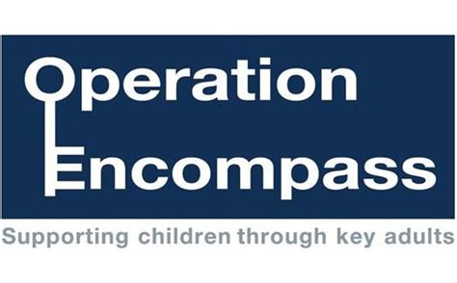
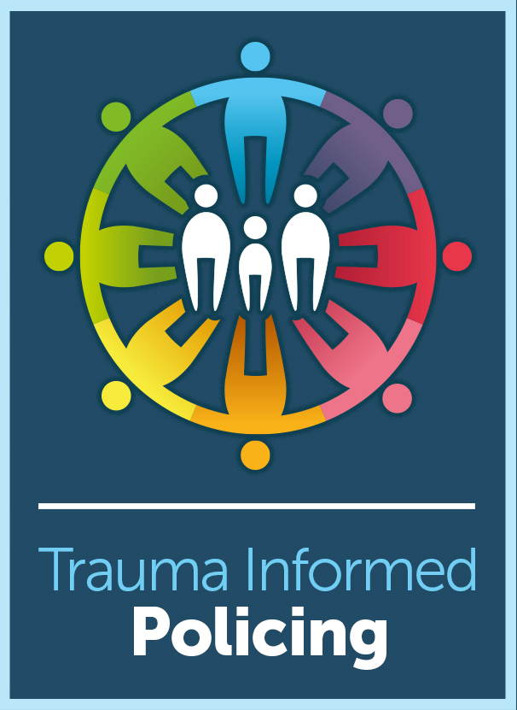

Operation Encompass is a unique Police and Education early intervention safeguarding partnership that supports children and young people exposed to domestic abuse.

Being part of Operation Encompass means that schools will receive a notification from Police Scotland before the start of the next school day when a child or young person has been involved in or exposed to a domestic abuse incident in the previous 24 hours.

The information is given in strict confidence to the school’s designated contacts who will be the Head Teacher, Depute Head Teacher, Child Protection Co-ordinator or Named Person.
This will enable support to be given dependent on the wellbeing needs and wishes of the child or young person.

The designated contacts have received an additional briefing about Operation Encompass and the impact of Domestic Abuse on children and young people. See below.

Operation Encompass supports us to get it right for every child and a phased implementation will begin across Ayrshire from Monday 29 April 2019.

Add presentation.

