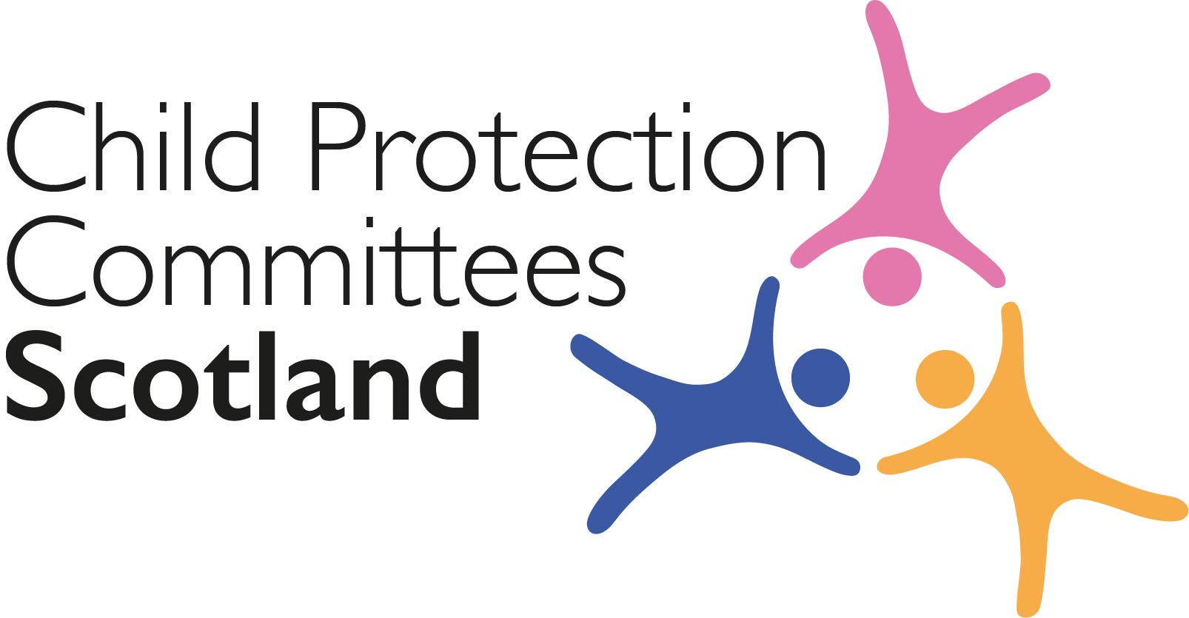
Keeping Connected - The CPCScotland Weekly Bulletin
Issue 20 - Tuesday 11th August 2020
Issued to support Child Protection Committee’s and partners with up to date information on child protection issues.
Welcome to Issue 20 of Keeping Connected.

I hope you are well.

I am sure for many of you both personally and professionally your focus this week will be on the return of pupils to school and nursery. I know you will all be preparing for a potential increase in notifications of concern from colleagues in Education as they have eyes on most children for the first time in many months. This issue of Keeping Connected has a number of sources of information and support for both professionals and for families which I hope you will find useful.

I am looking forward to our CPCScotland meeting on Thursday where our agenda has been designed to allow for a full discussion on two important areas, the consultation on the proposal to raise the age of referral to the Children’s Reporter and the revision of the FRAME guidance relating to risk assessment, risk management and risk reduction for the small number of children where their behaviour may pose a risk of serious harm or have caused serious harm to themselves or others. I hope to ‘virtually’ see many of you at the meeting.

Keep safe and keep in touch.

Alan Small; Chair Child Protection Committees Scotland

Section 1 COVID-19
Guidance, Resources and Information
1 Back to School

The Children’s Parliament has published ‘Back to School’, an online resource to support schools in taking a rights-based approach to recovery. The resource has been designed to help school staff to understand children’s experiences of lockdown and their wellbeing needs in the current context. The practical activities will support conversations between children, and between children and adults in school, giving time and space to pause, reflect and then recover.
https://backtoschool.scot/

2 Putting children first in future lockdowns

Anne Longfield, the Children’s Commissioner for England, has published a new paper on prioritising children and young people if there is another national COVID-19 lockdown and during local lockdowns, arguing that schools should close after pubs, restaurants and non-essential shops in this scenario.
https://www.childrenscommissioner.gov.uk/wp-content/uploads/2020/08/cco-putting-children-first-in-future-lockdowns.pdf

Jeane Freeman, the Scottish Government’s Health Secretary, has said that the Government is prepared to reintroduce some lockdown measures if these are needed to be able to reopen schools as planned: https://www.holyrood.com/news/view,further-lockdown-measures-possible-in-order-to-protect-schools-freeman-says

3 The impact of the coronavirus pandemic on child welfare: sexual abuse

This briefing uses insight from Childline counselling sessions and NSPCC helpline contacts to highlight the impact of child sexual abuse on children and young people during the coronavirus pandemic.
https://learning.nspcc.org.uk/media/2280/impact-of-coronavirus-pandemic-on-child-welfare-sexual-abuse.pdf

4 COVID-19 resources

Together have brought together a range of Coronavirus-related resources from across their membership and other organisations. This includes information for parents, carers, children and the third sector. https://www.togetherscotland.org.uk/resources-and-networks/coronavirus-resources/

5 Extension of Influenza (flu) vaccination programme to include social care staff

The Care Inspectorate, Scottish Care, the Coalition of Care and support Providers in Scotland and the Scottish Social Service Council have issued a joint statement in support of the Scottish Government's decision to extend health board free flu vaccine programmes to include certain social care staff including residential care and secure care for children https://www.careinspectorate.com/images/documents/coronavirus/flu_vaccination_joint_statement_v0.7.pdf?utm_medium=email&utm_source=govdelivery

6 Assessment of Scottish Government’s approach to COVID-19

Together has produced an updated assessment of Scottish Government’s approach to COVID-19 and the impact on children’s human rights.
The report considers the extent to which Scottish Government has implemented 11 recommendations issued by the UN Committee on the Rights of the Child in April 2020. The UN Committee’s statement set out what governments should do to take a children’s rights-based approach to the crisis.
https://www.togetherscotland.org.uk/news-and-events/news/2020/08/together-assesses-scottish-government-s-approach-to-covid-19/

7 Meeting the Challenge
CELCIS are continuing to add to the new ‘Meeting the Challenge of COVID-19’ resource. New this week:-
- How young people at Rossie Young People’s Trust helped their local community to feel more connected during lockdown.
https://www.celcis.org/knowledge-bank/spotlight/meeting-challenge-2/

8 Cyber Resilience Notice – COVID 19

The latest Cyber Resilience Notice (July 30th) along with all previous issues is available online.
https://blogs.gov.scot/cyber-resilience/2020/05/06/cyber-resilience-notice-covid-19/

9 Adult protection

Information on adult protection during COVID-19 can be found on the National APC Co-ordinator’s website:
https://napc.scot/

For Children, Families and Communities

10 Parentclub Back to School Stakeholder Toolkit

Following on from the information included in last week’s bulletin, the Parent Club ‘Back to School’ Stakeholder Toolkit has now been published and can be downloaded at the link below.
https://union.wetransfer.com/downloads/f959f0229c704f6e54531cdab720f02020200806210411/941bd3

11 Helping your child back to school after lockdown
NHS Grampian’s Child and Adolescent Mental health Service (CAMHS) has published a booklet for parents and children about going back to school after lockdown.
https://www.canva.com/design/DAEDXEEHAKI/Au7mxg2S-rUOt-X-_0R8Wg/view?

Research and Evidence Based Reports

12 Experiences of Virtual Children’s Hearings

CELCIS have published the results from the recent rapid consultation on experiences of virtual Children’s Hearings during lockdown, including a version for parents and carers, and a version for young people https://www.celcis.org/news/news-pages/experiences-virtual-childrens-hearings-captured-new-consultation/

13 COVID-19 pushed victims of child trafficking and exploitation into further isolation

A report by Save the Children has highlighted how the COVID-19 crisis has changed criminals’ usual models of trafficking and exploitation used on children and young people.
https://www.savethechildren.net/news/covid-19-pushed-victims-child-trafficking-and-exploitation-further-isolation-save-children

14 Babies in Lockdown

A report published by Best Beginnings, Home-Start UK and the Parent-Infant Foundation, has revealed the disproportionate impact of the COVID-19 public health emergency on those pregnant, giving birth or at home with a baby or toddler:
https://babiesinlockdown.info/download-our-report/

15 The State of Child Poverty 2020

Buttle UK has published a report on ‘The State of Child Poverty 2020’ based on a survey of nearly 1,000 frontline practitioners supporting children and families in crisis, which offers an insight into the impact of the COVID-19 public health emergency on some of the most vulnerable families in the UK – rising food poverty, lack of access to digital devices, and a sense of stigma are key factors preventing children from learning:
https://www.buttleuk.org/news/the-state-of-child-poverty-2020

16 ‘Online in Lockdown’ survey

Time for Inclusive Education (TIE) have published a report of a study which provides an insight into the experiences of young people in Scotland during lockdown. The research design focussed specifically on key areas: emotional wellbeing before and during lockdown and their experiences of online bullying, and experiences of online prejudice during lockdown.
They found a considerable difference within all key themes across demographics. LGBT+ young people report a different experience from heterosexual young people, as do girls and young women when compared with boys and young men.
You can download the report from the Together website.
https://www.togetherscotland.org.uk/news-and-events/news/2020/08/results-of-online-in-lockdown-survey-released/

17 Children and Young People’s Participation in Crisis

A Place in Childhood have published the findings of a project examining the wellbeing and participation of children and young people in the crisis response to COVID-19.
http://aplaceinchildhood.org/wp-content/uploads/2020/07/ScotYouthandCOVID-report-Jul-2020.pdf

18 The impact of COVID-19 on young carers

The findings, gathered by Carers Trust Scotland, highlight that many young carers have experienced increased pressures due to COVID-19. This has had a negative impact on young carers’ mental health and wellbeing.
https://carers.org/downloads/scotland-pdfs/2020-vision.pdf

News and Opinion

19 In the Media

- Research by the Women’s Resource Centre has found that the number of babies being taken into care during the COVID-19 public health emergency has increased, which may be due to factors such as worsening mental health of mothers, increased rates of domestic abuse, and rising poverty and economic uncertainty: https://www.independent.co.uk/news/uk/home-news/children-care-mothers-coronavirus-lockdown-a9651586.html

- As Scottish schools prepare for phased re-openings to return after the COVID-19 public health emergency closure this week with one-way corridors, hand washing stations and temporary classrooms, teachers’ unions and parent groups have expressed concerns about a lack of clarity https://www.theguardian.com/education/2020/aug/09/no-hugs-and-one-way-corridors-scotland-prepares-for-school-in-shadow-of-covid-19

- The Scottish Qualifications Authority (SQA) is facing criticism after downgrading over 100,000 predicted exam results submitted by teachers, with some claiming pupils have suffered because of their school’s location and historic performance, not their ability:
https://www.theguardian.com/uk-news/2020/aug/04/sqa-under-fire-after-rejecting-124000-exam-recommendations

- On Tuesday 11 August the Scottish Government’s Education Secretary John Swinney will make a statement to the Scottish Parliament on the Scottish Qualifications Authority (SQA)’s handling of exam results and the ‘downgrading’ of some results from grades predicted by teachers to be in line with schools’ past performance rather than based on evidence of individual pupils’ ability:
https://www.holyrood.com/news/view,john-swinney-says-he-has-heard-the-anger-of-students-ahead-of-exams-statement

Section 2 Other Child Protection Topics

Guidance, Resources and Information

21 Safeguarding: identify, understand and respond appropriately to sexual behaviours in young people

The National Improvement Hub has published an online webpage designed to help staff in education and training settings, from early years to senior level and including ASN/EASN provision, to identify, understand and respond appropriately to sexual behaviours in young people. The webpage provides brief information as well as links to relevant guidance and resources on harmful sexual behaviour.
https://education.gov.scot/improvement/learning-resources/safeguarding-identify-understand-and-respond-appropriately-to-sexual-behaviours-in-young-people/

22 Child Participation Podcast

Children in Scotland’s podcast explores how professionals can ensure they are taking a child’s rights-based approach in their work by facilitating meaningful participation.
https://www.youtube.com/watch?v=UDusd6bbUGU&feature=youtu.be

23 Proposed Right to Food
Elaine Smith MSP has lodged a proposal for a Bill to enshrine the Right to Food into law in Scotland. Consultation on the Bill is now open with a closing date for responses of 15th September 2020.
https://0b509398-ac35-4538-ba0c-adb1dd66c9be.filesusr.com/ugd/1bee5b_e0fbf49185a34cca8d78942121d1f4f8.pdf
Training

24 Active Listening Online Training

YouthLink Scotland is running a free online training session that aims to help professionals who work with young people to find effective ways to connect with young people via tools such as Zoom. The training is on 11th August from 12:00-12:45.
https://www.youthlinkscotland.org/events/august-2020/take-active-listening-online/

25 Safe & Together Training

All Safe & Together training can be accessed online. Some courses are available free of charge however for other courses a charge applies.
https://safeandtogetherinstitute.com/what-we-offer/

News and Opinion

26 In the Media

- Statistics from the Crown Prosecution Service in England show that, despite the increasing number of police recorded rapes over the past five years, the prosecution rate has reduced. The data also reveals the victims suffering from the worst outcomes are children.
https://www.spectator.co.uk/article/child-sexual-abuse-survivors-are-being-let-down

27 Making Care Count in Scotland

A new briefing from Oxfam Scotland explores the link between the under-valuing of care work in Scotland, including childcare, and increasing poverty levels. It calls on the Scottish Government to use its devolved powers to protect low income families.
https://oxfamapps.org/scotland/wp-content/uploads/2020/07/Making-Care-Count-in-Scotland-Oxfam-Scotland-July-2020-1.pdf

Please feel free to let us know what you think about the bulletin and provide information for inclusion in future editions. Please contact Alan Small or Susan Mitchell at cpcscotland-liaison@strath.ac.uk. Please note that the information included in this bulletin is provided in good faith. Inclusion does not indicate CPCScotland endorsement of the content of the linked documents or websites.

