GETTING
August 2023 Version 1.1
IT
RIGHT
FOR EVERY CHILD in AYRSHIRE
Named person service in East Ayrshire | For more information  Access www.girfec-ayrshire.co.uk  In the absence of knowing who the named person is, please contact the Named person service, as follows:  Contact the named person for school aged children in East Ayrshire through the Education Named person service e-mail:  Namedpersonservice@east-ayrshire.gov.uk  Or by calling 01563 555653  Contact the named person for Health Visiting Services within East Ayrshire at:  Clinical_EastAyrshireChildrensHealth @aapct.scot.nhs.uk  Or by calling 01563 545730  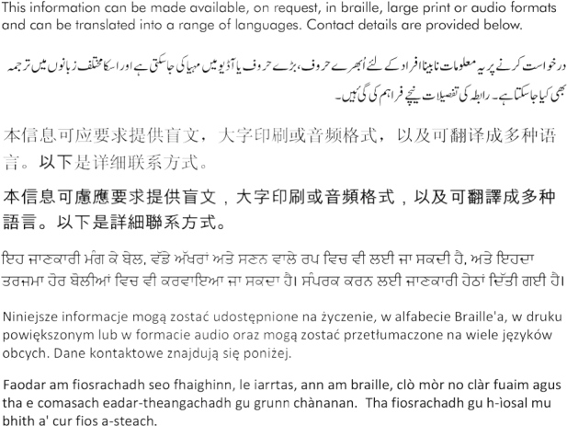
Getting it right for every child is the national approach in Scotland to support and improve the wellbeing of our children and young people by offering the right help at the right rime from the right people.

The named person is a professional within Health and Educational Services who is responsible for promoting, supporting and safeguarding the wellbeing of children and young people.

Parents, carers, wider family members and the community provide most children and young people with the help and support they require. Through Getting it right for every child all children, young people and their families have access to a named person so that they can request extra support, advice or sign posting to other services when they need it.

Every child and young person has a named person until they reach the age of 18 years old or until they leave school if over the age of 18.

The named person works with children, young people and their families to improve wellbeing and help each child/young person achieve their potential. If the named person requires to share information to achieve this they will ask for consent from the young person or the child’s parents unless there are child protection concerns.

There is no obligation to accept the offer of advice or support from the named person. The views of all those involved will be considered and recorded.

