MY FOLDERS

The My Folders tab shows the folders of a child/young person for whom you are Named Person/Lead Professional (NP/LP) or linked contact.

Open a folder by clicking on the ‘Folder’ icon (Fig 1).

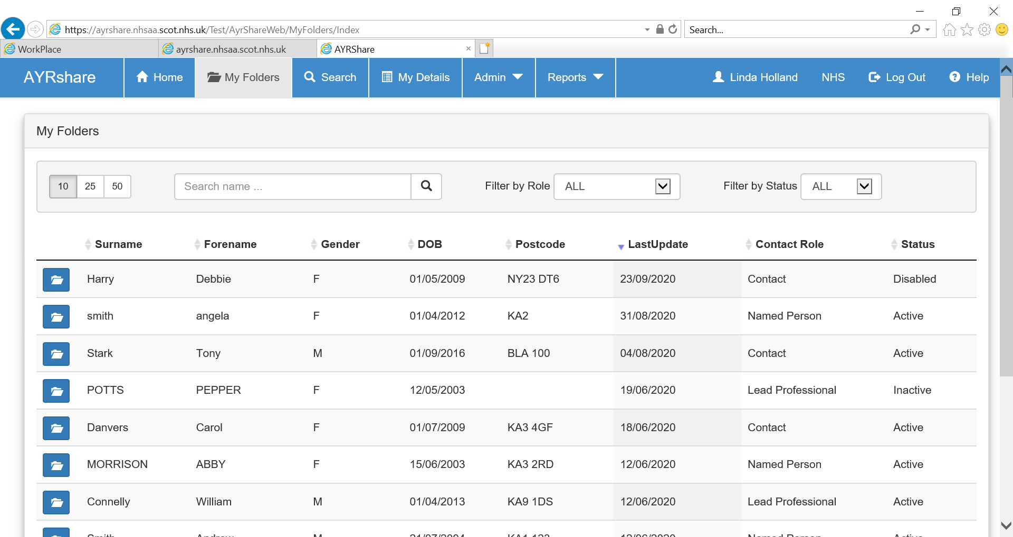
2
1

The status of any folder is shown at the right hand side of the page (Fig 2). Disabled means the sharing has been manually switched off, inactive means the sharing has expired, and active means the folder is live.

CHILD’S FOLDER
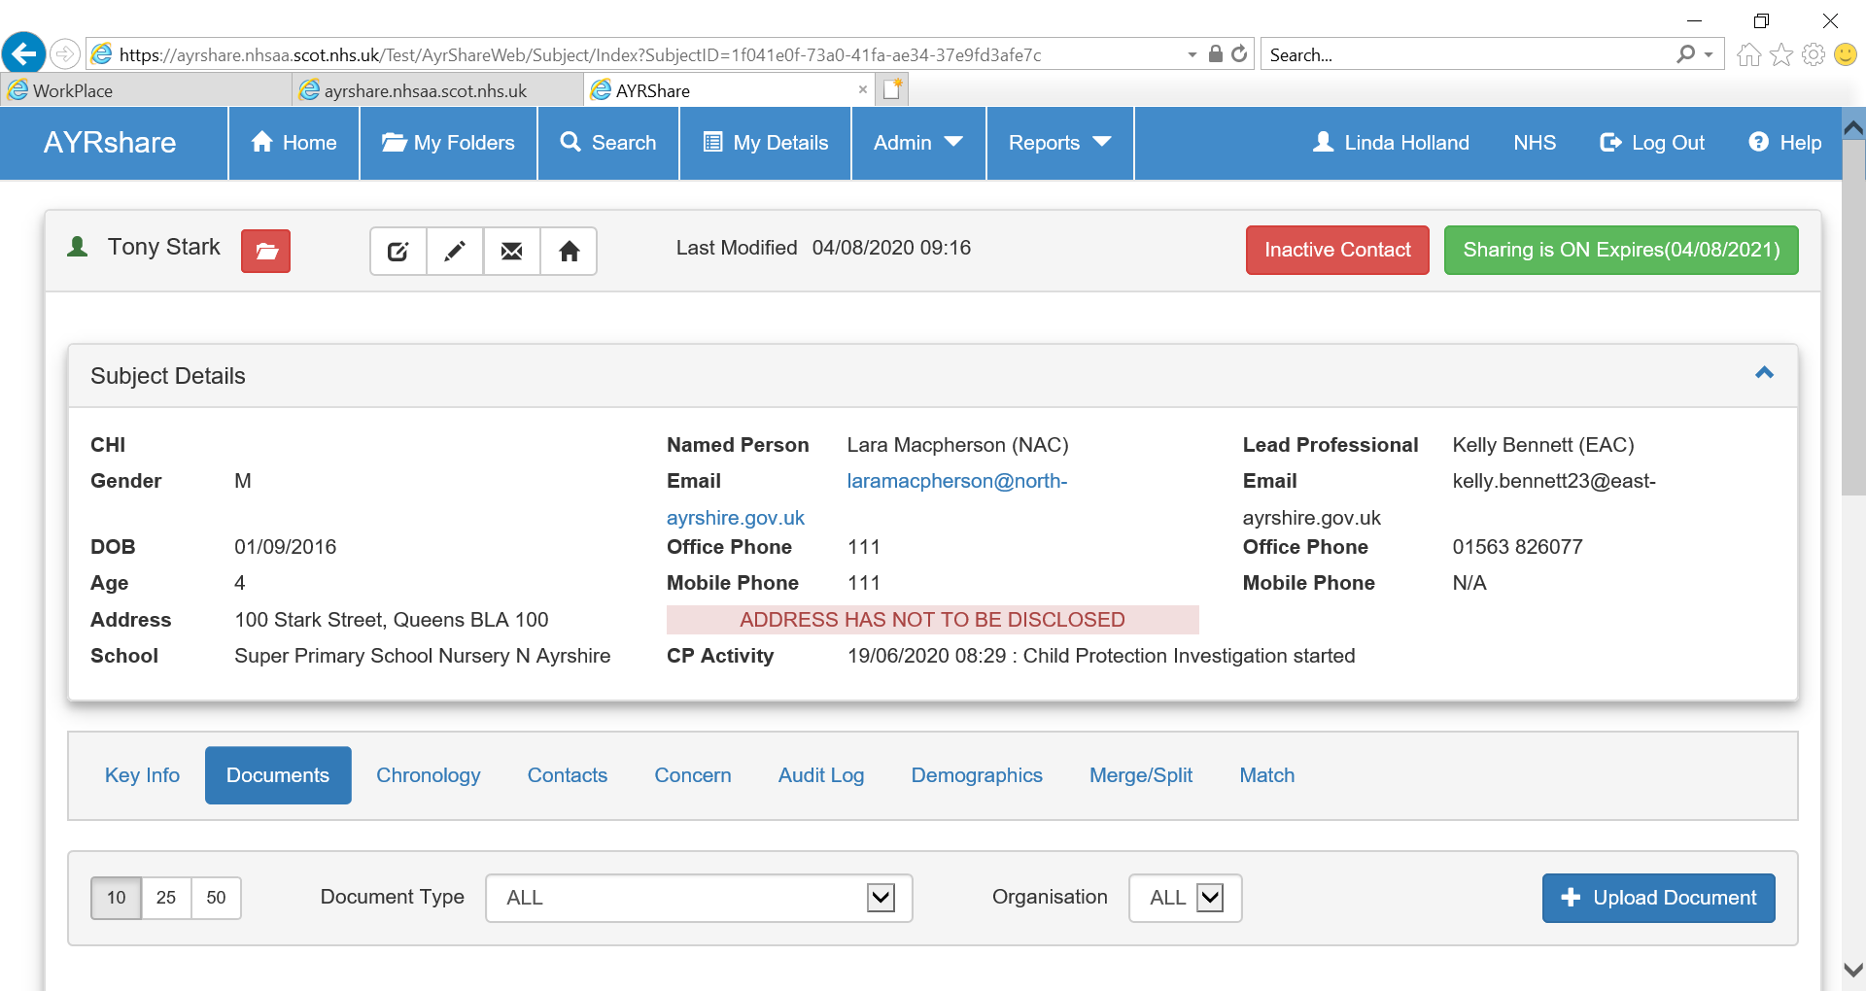
6
5

4

3

2

1
Fig 1. Demographic details:
Local Admin, System Admin, NP and LP can update an address and System Admin can update all demographics.
4
NP, LP, Local Admin and System Admin can add school details by clicking on the ‘Notepad’ icon. Type and save the school details.

Fig 2. Child Protection Messaging:
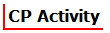This section shows the current status of Child Protection Activity. This function is used at present by North Ayrshire Council and East Ayrshire Council.

Fig 3. Named Person/Lead Professional:
Contact telephone numbers and email address.

Fig 4. Sharing:
NP/LP can extend sharing of the child/young person’s folder by extending and saving the displayed date or they can Stop/Start sharing the folder.

Fig 5 and Fig 6. Non-Disclosure Of Address:
Any child’s folder where it has been specified that the address should not be disclosed is shown here (Fig 6). To access the relevant field to mark the folder as a non-disclosure, click on the tab at Fig 5.

AYRshare is connected to some systems used by social work and health. This allows users of these systems to share certain documents and chronology from these systems by choosing the ‘Share to AYRshare’ option from their own system. The Document and Chronology section below show how to manually add information to a child’s folder which should only be done by those who don’t have a linking system.

DOCUMENTS

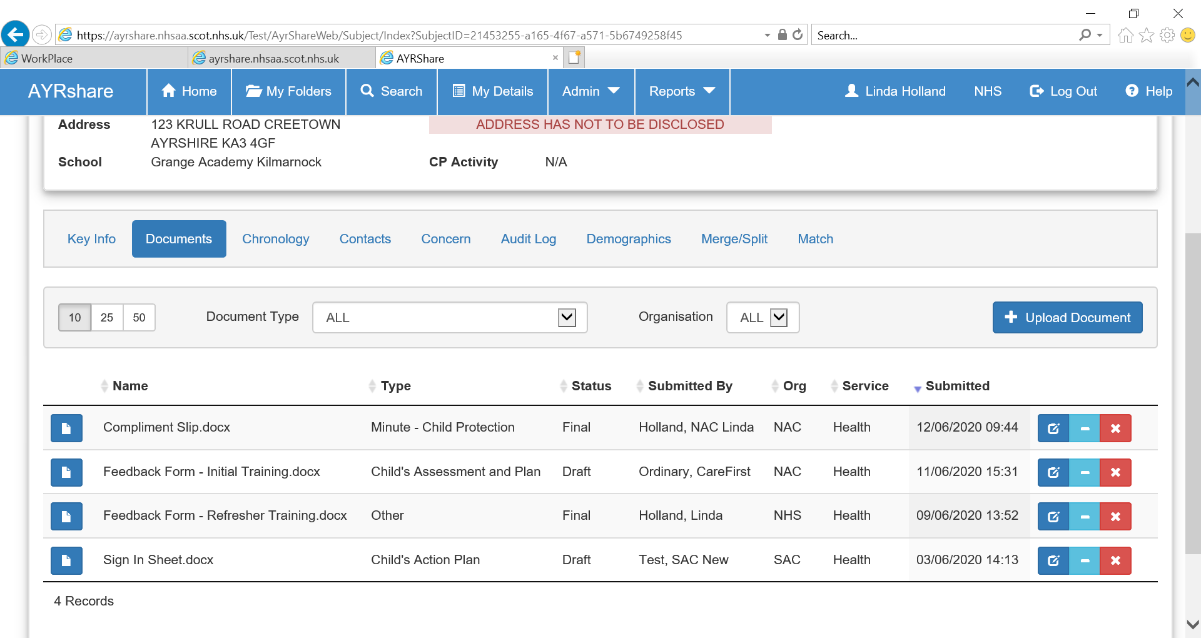
2

1

Click on the ‘Document Name’ or ‘Folder’ icon (Fig 1) to open and read the contents of a document.
If your system is not connected to AYRshare you can manually upload a document by clicking on ‘Upload Document’ (Fig 2). Browse, choose file to upload then select the document ‘Type’ and ‘Status’ from the options. Then click ‘Upload Document’.
The NP/LP and Local Admin can delete documents. The NP/LP can also withdraw documents as can the local admin user.

CHRONOLOGY

In the Chronology tab significant events can be manually added by clicking on ‘Add Event’ (Fig 1). This should only be used by those whose system does not link to AYRshare.
When the new page opens complete all fields, including the dropdown options Category and Significance (Fig 2). To keep the Chronology concise there is a 250 character limit in the Significant Event box and a 500 character limit in the Outcome/Action taken box.

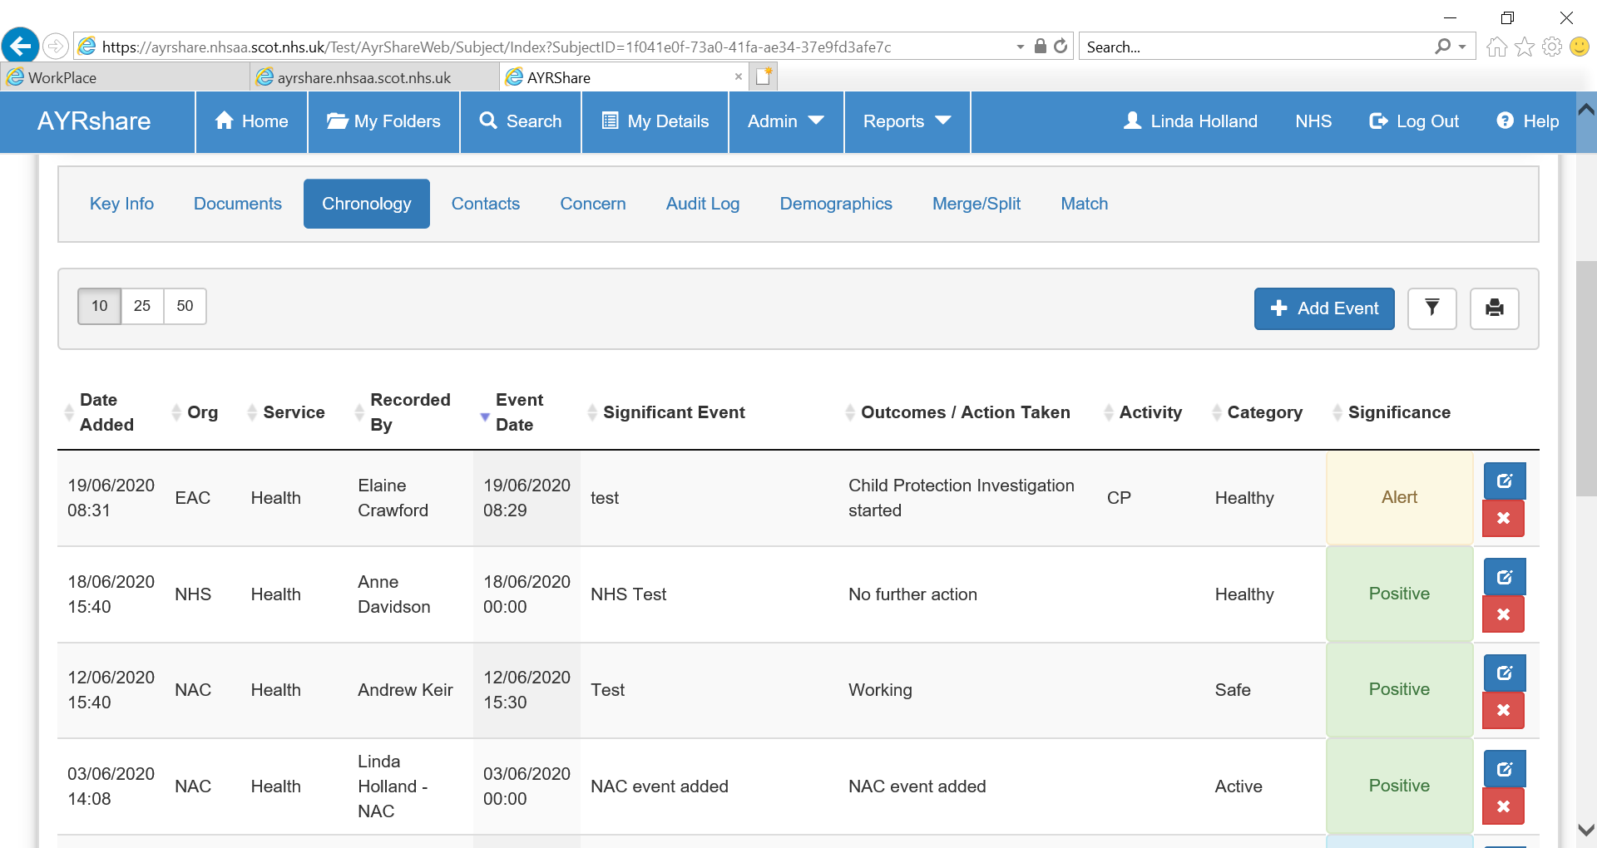
1

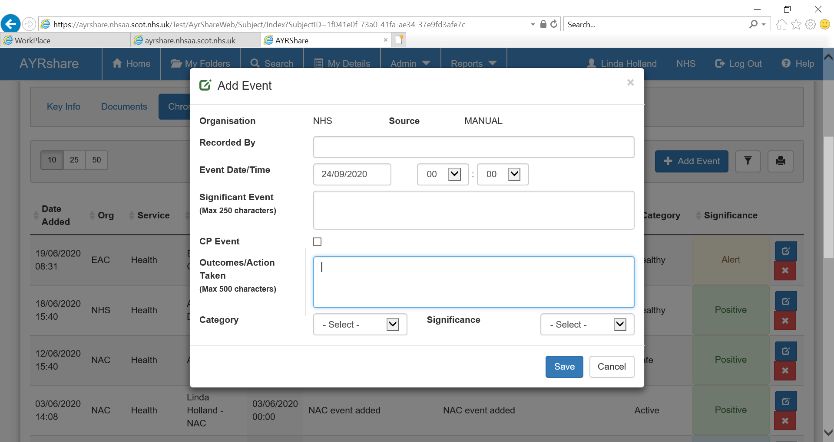Detail of the Significant Event should be included in the Child’s Plan as appropriate.

2

CONTACTS

To view the list of Contacts for the child/young person, click on the Contacts tab. The NP/LP, Local Admin and System Admin can add contacts and their role i.e. NP/LP to a child/young person’s folder. Only people with an AYRshare account can be added as a contact.

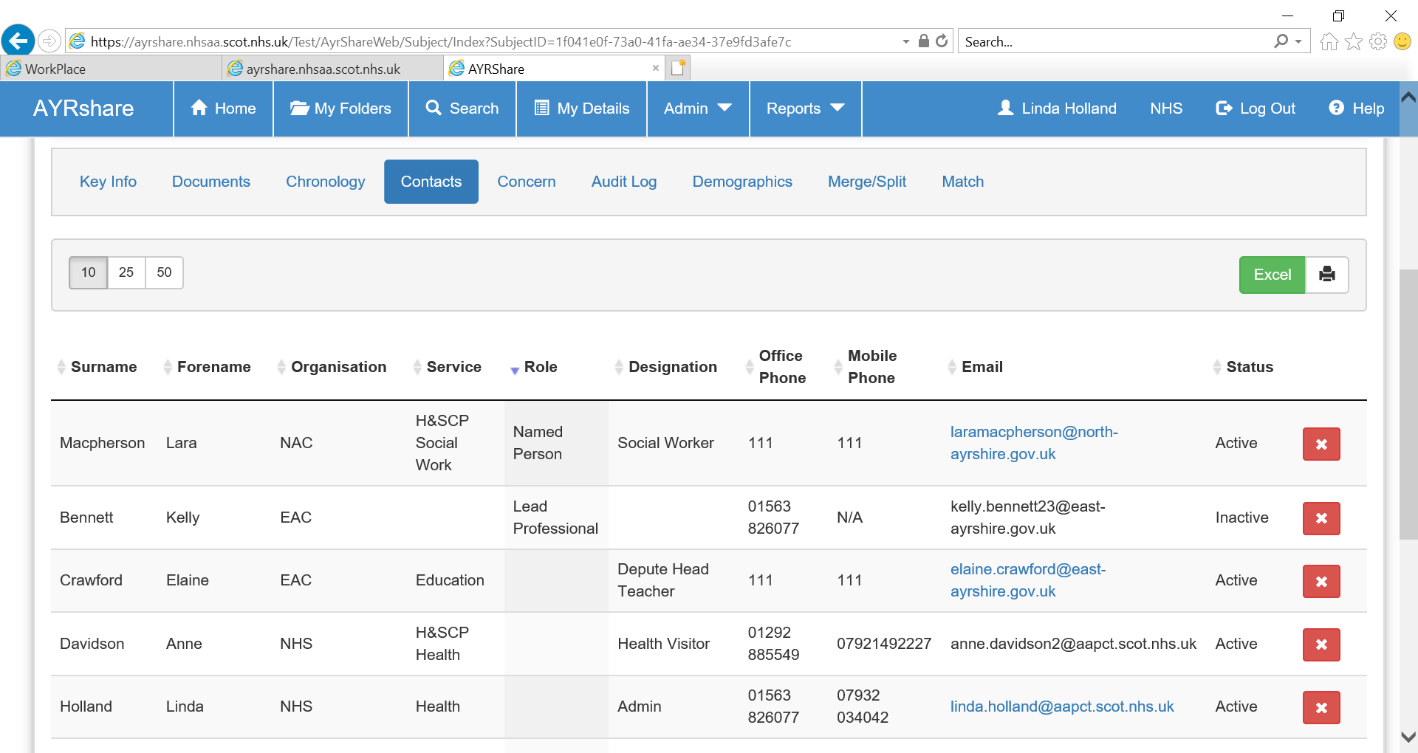
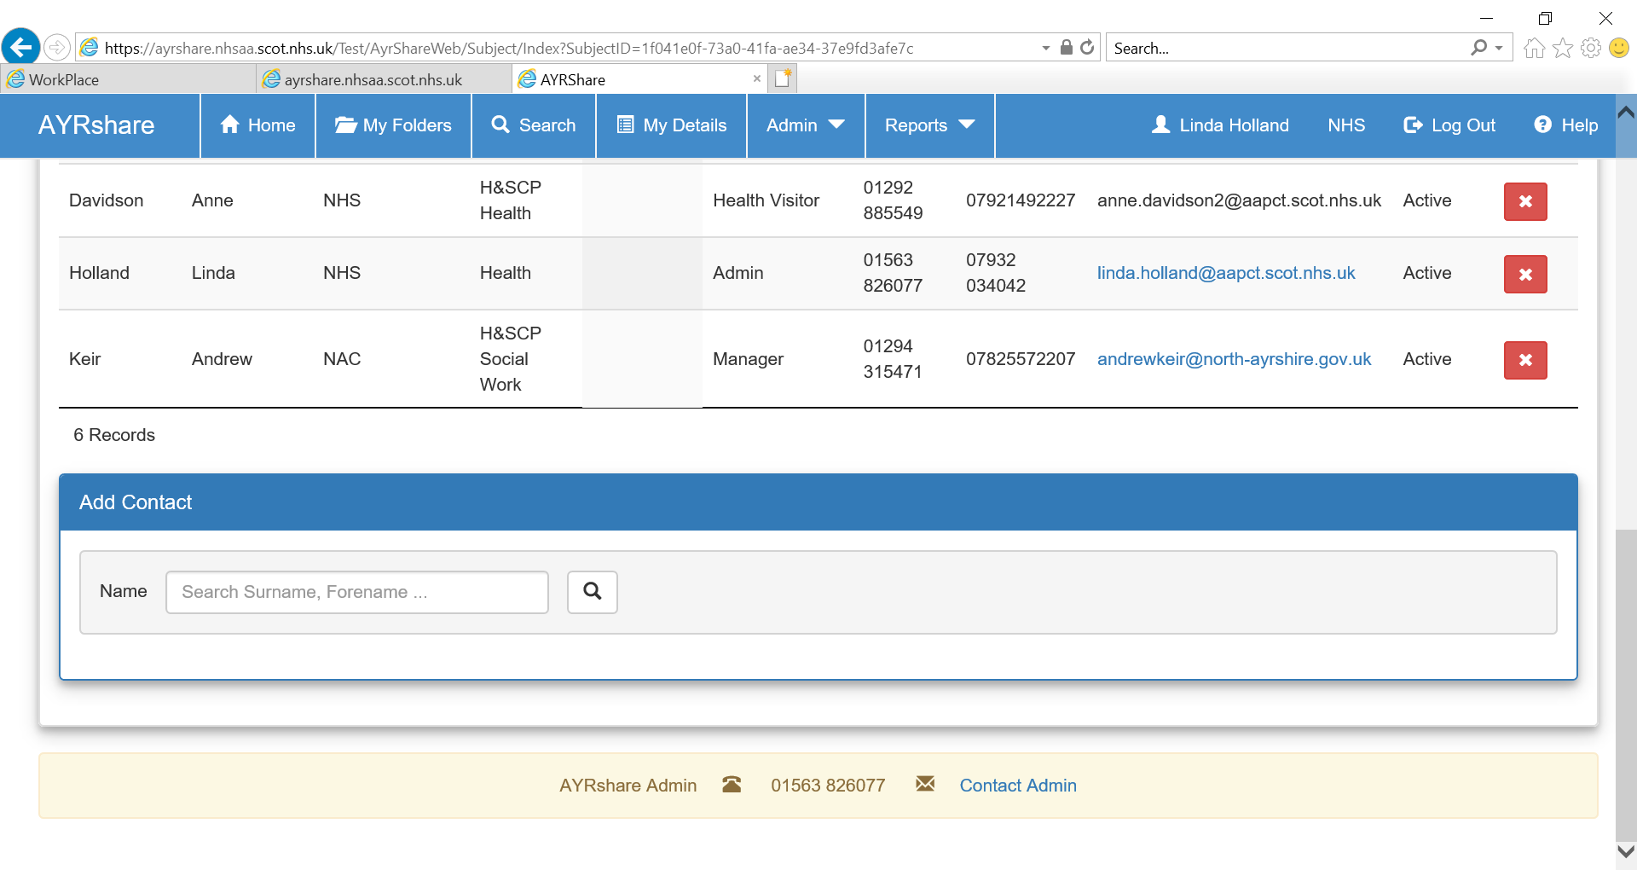
2

1

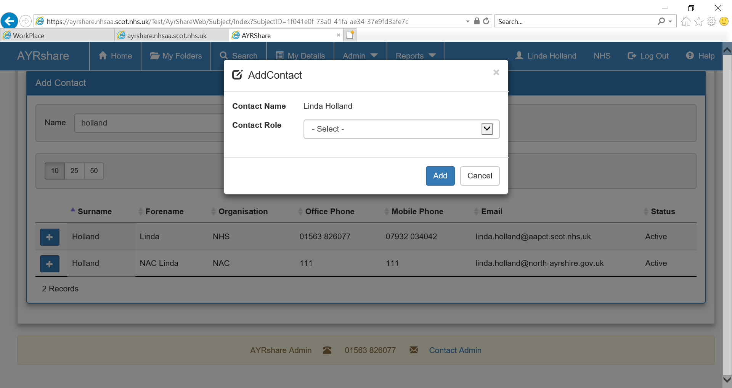
Search for the person you wish to add as a NP/LP or contact in the ‘Add Contact’ section (Fig 1). Choose their role from the dropdown options and click on ‘Add”. To remove a NP, LP or contacts from the folder click on the ‘Red X’ next to their name (Fig 2).

SEARCH

To check if a child/young person has an AYRshare folder click on the Search tab (Fig 1).
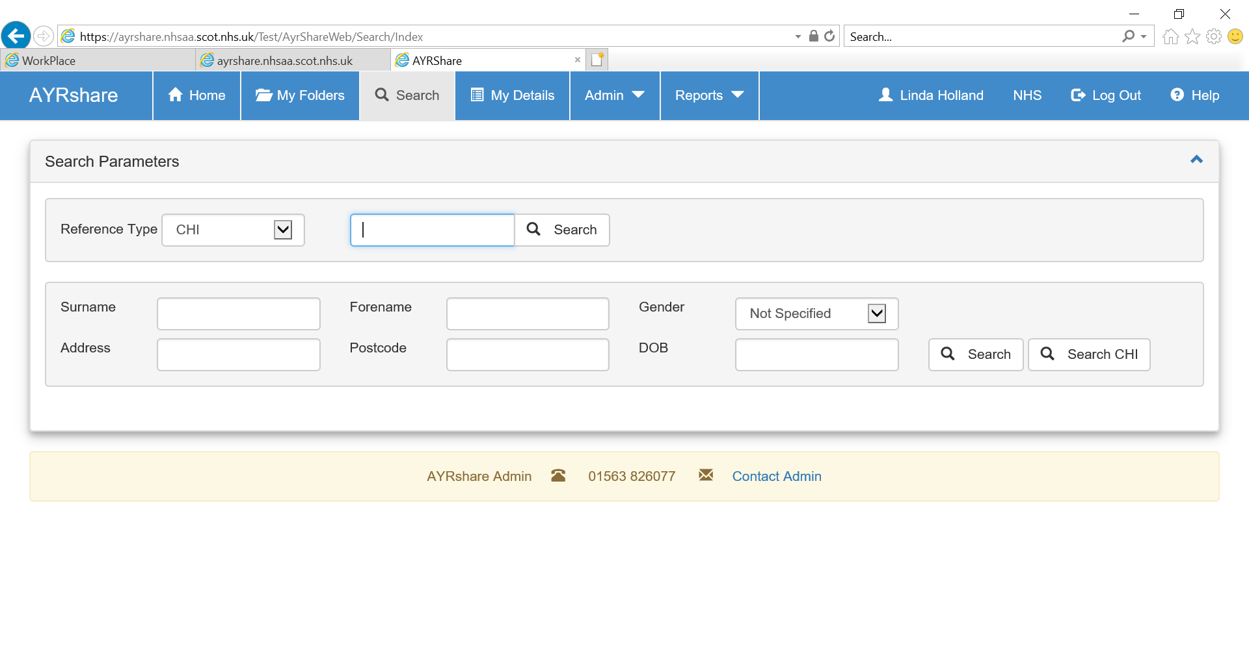
2

1

If you have a unique identifier, you can search by ‘Reference Type’ (Fig 2) . Alternatively you can search by a minimum of three demographic details in the bottom section (Fig 3). When you have input your search criteria click on the ‘Search’ button to see the AYRshare search results.

If the folder you are looking for is displayed contact the Named Person if you wish to be added as a contact.

When the folder you are looking for is not found in the search results the ‘Create New Folder’ box is available here for you to manually create the folder. Only the NP/LP or Admin have permission to create a new folder (Fig 4).

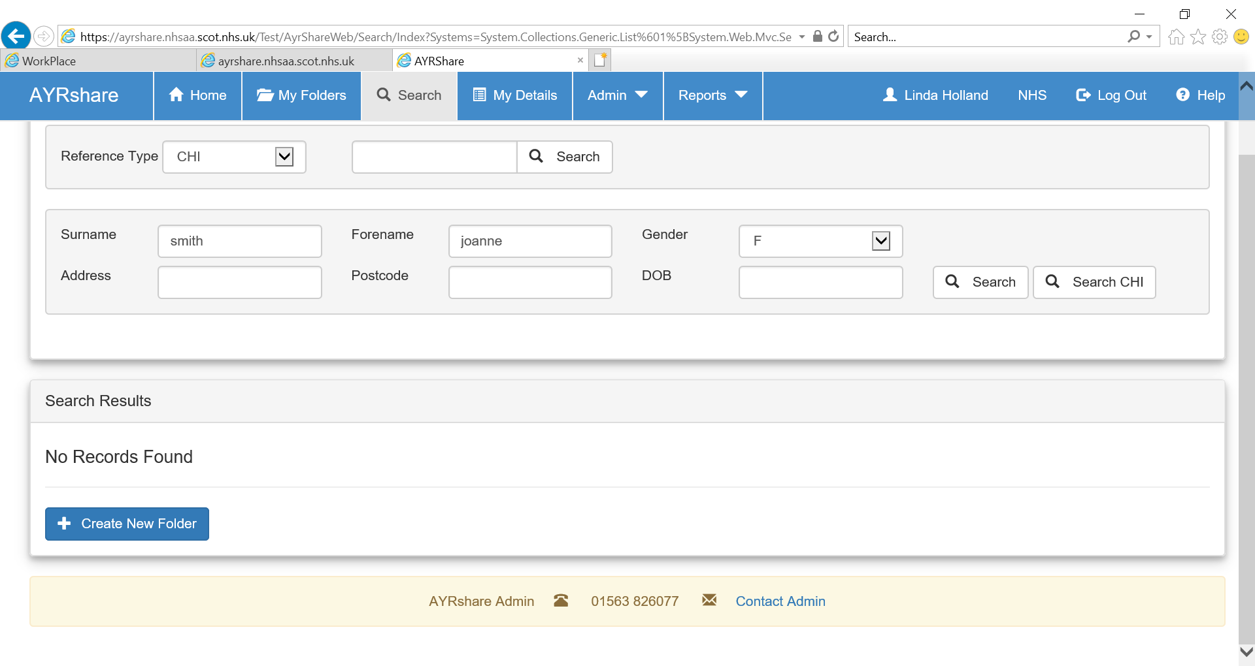
4

HELP SECTION
Open the AYRshare Help Section by clicking on the after the Logout tab.

You can view the full version of the AYRshare User Guide in the Help Section along with other useful information.
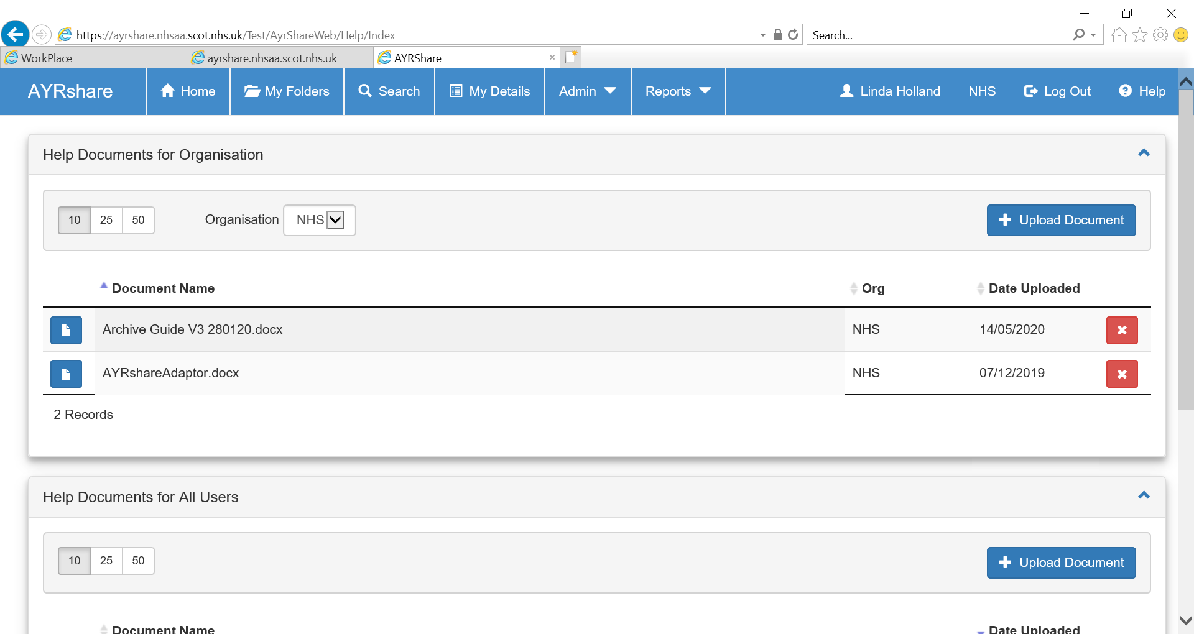

AYRSHARE ADMINISTRATOR

All AYRshare queries should be directed to AYRshare Admin. You can either telephone or click on the link at the bottom of each page on the system to send an email. If you are not logged into AYRshare include your name so the administrator knows who to reply to.

Connection/Network issues should be sent to Service Now, or your own organisations IT Helpdesk.

