



**ORDINARY USER GUIDE**

**V7**



**CONTENTS**

To view a specific section of this user guide hover over the contents below and follow the instructions.

INTRODUCTION 3

GETTING STARTED 4

AYRSHARE ACCOUNTS 5

HOME SCREEN 7

MY FOLDERS 8

SEARCH 8

CREATING A NEW FOLDER 10

FOLDERS 10

ENABLING OR DISABLING SHARING (NP/LP) 12

KEY INFO 13

DOCUMENTS 13

UPLOADING A DOCUMENT 14

DELETING A DOCUMENT (NP/LP) 14

WITHDRAWING A DOCUMENT (NP/LP) 15

EDITING A DOCUMENT (NP/LP) 15

CHRONOLOGY 15

CHILD PROTECTION MESSAGING 17

CONTACTS 18

CONCERNS 19

AUDIT LOG (NP/LP) 19

ACTIVITY LOG 20

DEMOGRAPHICS 20

MY DETAILS 20

PASSWORD RESET 21

REPORTING ISSUES/FAULTS WITH THE SYSTEM 22

HELP SECTION 23

LOGGING OUT 24

# INTRODUCTION

“To improve the well-being of children and young people through the implementation of a secure, shared information system that will enable coordinated and efficient support by well-informed personnel, working in partnership to achieve appropriate and timely interventions, and improved outcomes.”

AYRshare Vision Statement 2012

An electronic information sharing system has been developed within Ayrshire. This system is known as AYRshare, and supports the practice and enhances information sharing between professionals involved with a child or young person.

An AYRshare folder can be opened by a child or young persons Named Person or Lead Professional when it is identified that assessment information is required to be shared to maximise outcomes.

# GETTING STARTED

Following formal training, you will be required to complete the relevant system access form for your role. The form is available from the AYRshare System Administration Team. When completed and signed by yourself and your line manager (and the appropriate senior manager if you are gaining access as an Emergency User) send it to the AYRshare System Administration Team. The contact details are located at the bottom of the form. If there are no issues with the form then the AYRshare System Administration Team will set up your account.

When your account is created on AYRshare, you will receive two emails. One will be from the AYRshare System and contain a link that when opened will take you to the AYRshare login screen.

Opening AYRshare from this initial link will allow you to verify your email address and account details. Only verified accounts will receive notification emails from the system.

The second e-mail will be from the AYRshare System Administration Team and will contain details of your username and temporary password.

A quick guide on adding AYRshare to your desktop or favourites bar will be attached on the original e-mail, and can also be found in the AYRshare system help section.

When you enter the allocated password, you will be prompted to create your own strong password (Minimum of eight characters using a mix of three: uppercase, lowercase, numbers or symbols e.g. Ayrshare1). The new password you set will gain you access for the next 90 days before you will be asked to change it. Should you not access the system within a 90-day period AYRshare will automatically disable your account. However, users with verified accounts will receive an email notification 28 days prior to their account being disabled asking them to login to keep the account active. In the event of a system users account being automatically disabled you will be required to contact the AYRshare System Administration Team to reactivate your account.

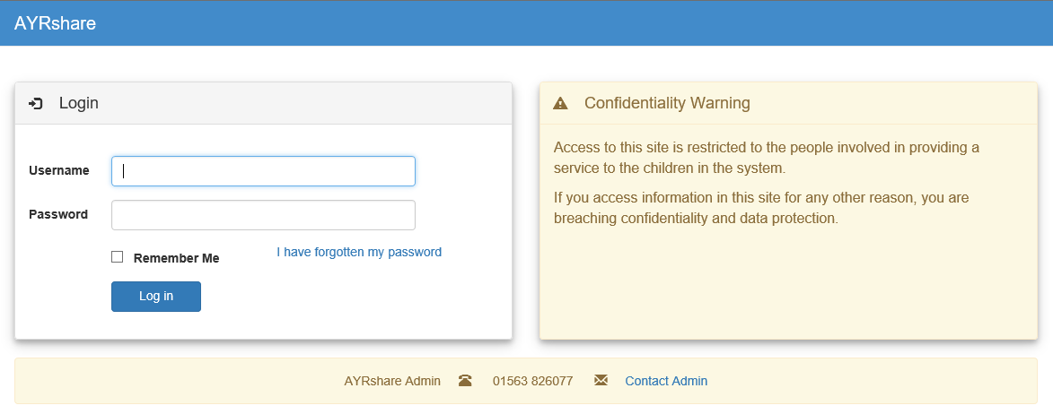

# AYRSHARE ACCOUNTS

There are seven user account types on AYRshare:

**Ordinary User**

The Ordinary User role only has access to a folder on AYRshare when they are linked as a Contact. The level of access to each folder differs depending on whether you are the Named Person or Lead Professional (NP/LP) or an Ordinary Contact.

The NP/LP maintains the Contact List for each folder. All Ordinary Users can view and add new information such as documents and chronology events to folders either manually or directly from their own system. However only Ordinary Users designated as a NP/LP can edit or delete chronology events and delete documents from a folder.

**Emergency User**

The Emergency User role has access to all folders on AYRshare and can search and view any folder that they require in the case of an emergency. An Emergency User could be someone from Out Of Hours Social Work. Although an Emergency User has access to all folders on AYRshare, they can only view folders as an ordinary linked contact unless they are already linked to the folder as a NP/LP.

**Local Admin**

Local Admin is a user set up to manage AYRshare folders from their area on behalf of the NP/LP. As a Local Admin your responsibilities will be:

* Creating new AYRshare folders with approval from the NP/LP (if the record already exists in a system linked to AYRshare then this should be pushed across from that system and not manually created).
* Granting the NP/LP access to newly created folders
* Identifying a user’s caseload
* Updating AYRshare with the Child/Young Persons current address
* Updating school details
* Maintaining Local Admin List New tab

**System Administrator**

AYRshare Administrators have full access to all folders on AYRshare. An Administrator can create and update system user’s accounts. They can also merge, split, match and delete folders.

**Manager**

The Manager role on AYRshare allows a designated user to see relevant reports, and access records within their locality.

The Manager’s role also allows designated Users to be the Named Person/Lead Professional where circumstances require this, i.e. vacant case load, records yet to be allocated.

**Quality Controller**

The Quality Controller (QC) role on AYRshare allows a designated user to monitor the quality of the contents of an AYRshare folder.

As QC, you will be responsible for:

* Accessing Concern Forms Watch List which allows QC to view concern tab and monitor whether NP has viewed form and recorded outcomes
* Concern Forms Volume
* List Empty Report, which details all records for your organisation that have no activity in them at all i.e. no documents, chronology events
* Monitoring the quality of information within random folders for your organisation held in the QC Folders tab

**Notifier**

The Notifier role has very limited access to AYRshare and cannot access any records. Their sole purpose is to upload a Concern Form.

# HOME SCREEN

The Home Screen has three main sections:

* AYRshare Website Notifications: This will notify users of any issues or changes to the system e.g., when system will be unavailable due to maintenance.

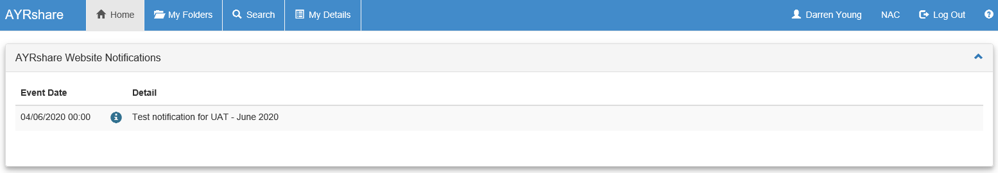

* Recent Login History: This shows you the last times you have logged into the system allowing you to monitor for any irregularities e.g. the login history showing you as logged in when you were not or any failed login attempts that were not you. If the login history is not accurate, change your password immediately and contact AYRshare System Administration Team.

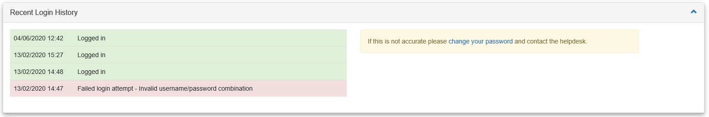

* Summary of Recent Activity: You will be notified by email of any updates to folders that you are a Contact on, assuming you have verified your AYRshare account. As well as receiving an email notification from the system, a history of your notifications will be available here. After 3 months, these notifications will disappear from the Home page.

For example: if a new chronology event has been added to a folder you are linked to it will appear here as a notification as well as an email in your inbox. Users can enter a Child/Young Person’s folder directly from here by clicking on the folder or name of the Child/Young Person. The email notification will have a description of the event and a link to click taking you directly to the relevant Child/Young Person’s folder.

If removed as a contact from a child/young person’s folder you will still be able to view the child’s name, notification date added, event description and user information in your notification history for a period of time. If you click on the folder icon next to a child’s name you have been removed from you will be shown an ‘Access to Subject Record Denied’ message. This means you can no longer view the contents of the child’s folder.

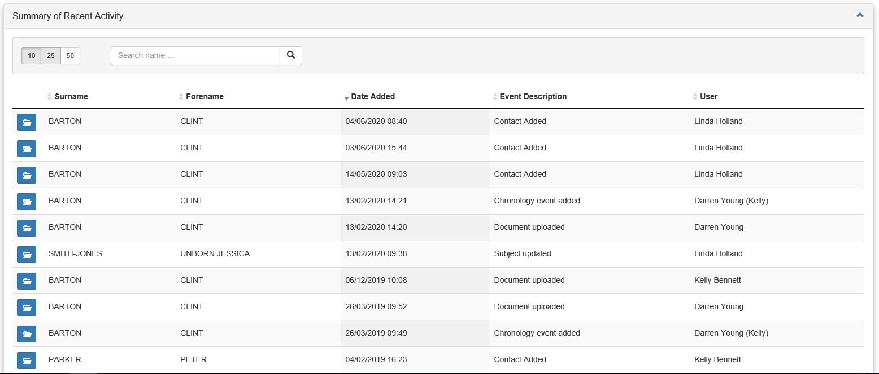All of the sections on the Home Screen can be collapsed by clicking on the  in the top right corner.

# MY FOLDERS

The My Folders tab displays folders containing information relating to a Child/Young Person for whom you are a linked Contact whether you are a NP, LP or Contact.

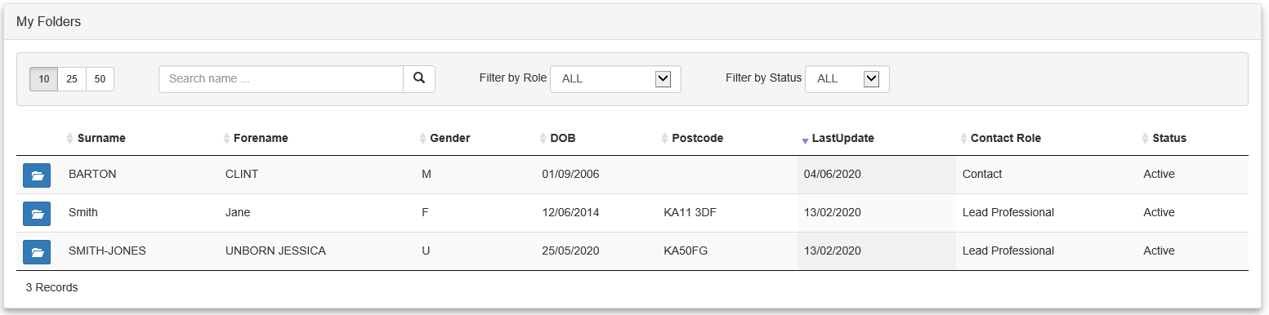

My Folders tab allows you access to any Child/Young Person you are a Contact for by clicking on the folder icon.

All fields can be sorted by clicking the arrows next to the header of a column. You can also search using the search tab and filter by role or status.

The status of all folders is displayed in the last column. Please note any folders that state they are Inactive have sharing expired and unless you are NP/LP you will be unable to open them.

# SEARCH

The Search screen is the same for all users and works in two ways:

1. Searching using a unique reference type:

* CHI (Community Health Index)
* CareFirst/CareFirstSAC (NAC and SAC Social Work System)
* FACE/Care Partner (NHS System)
* Liquid Logic (EAC Social Work System)

1. Searching using a minimum of 3 demographic identifiers from:

* Gender – Male, Female, Unborn and Any (Any does not count as a demographic detail) (Gender is the one field, of the 3, which MUST be selected to allow the search to go ahead).
* Forename
* Surname
* Date of Birth
* Address
* Postcode

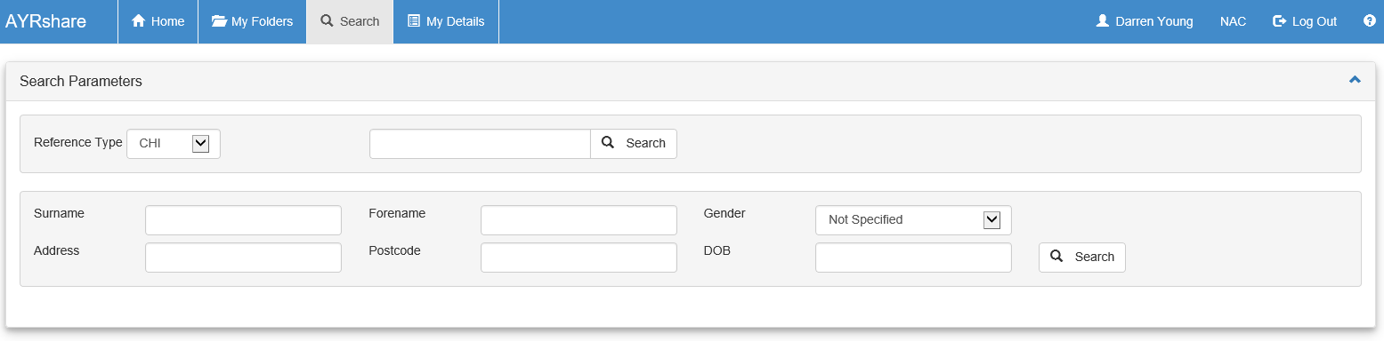

After you have entered the search criteria click on the ‘Search’ button to see any results.

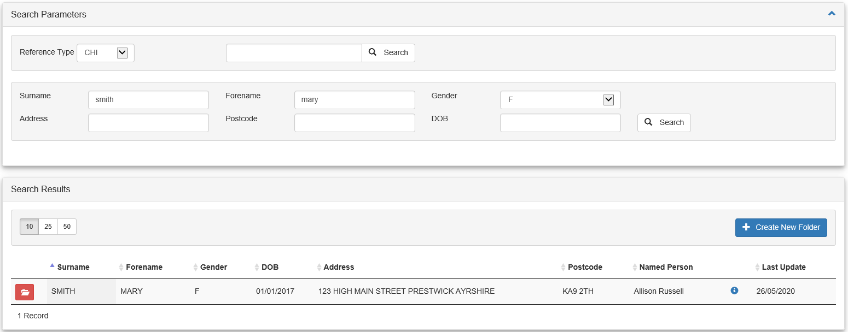

The results show the Child/Young Person’s basic demographic information and the NP’s contact details by clicking the  button. Note that the folder is red in the screenshot above. This will appear if you are not a linked Contact for the Child/Young Person, therefore you will not have access to the folder. If you require access to this Child/Young Person’s folder, you should contact the NP listed by clicking on the red folder and sending a request or your own Local Admin.

If you are a Contact or an Emergency User then the ‘Blue Folder’ icon will appear instead allowing you to open the folder.

However, if you click on the folder and see the message ‘Access denied, sharing expired’ the sharing of the folder has expired and the NP or LP, if known, should be contacted and asked to extend to allow you to view and add information to the folder.

# CREATING A NEW FOLDER

If the folder that you have searched for does not appear on AYRshare, a folder can be manually created, UNLESS the User has access to CarePartner, Care First or Liquid Logic. (You should consult your local Systems Team if you require further guidance on how information is shared to AYRshare).

If a manual creation is required, the following guidelines should be adhered to. Click on ‘Create New Folder’ once a search has been run, the criteria that you have searched is already filled in, you can then manually complete the rest of the demographic information and click on the ‘Create’ button. If you do not fill in all of the criteria an error message will be displayed to highlight the areas missed and required for creation.

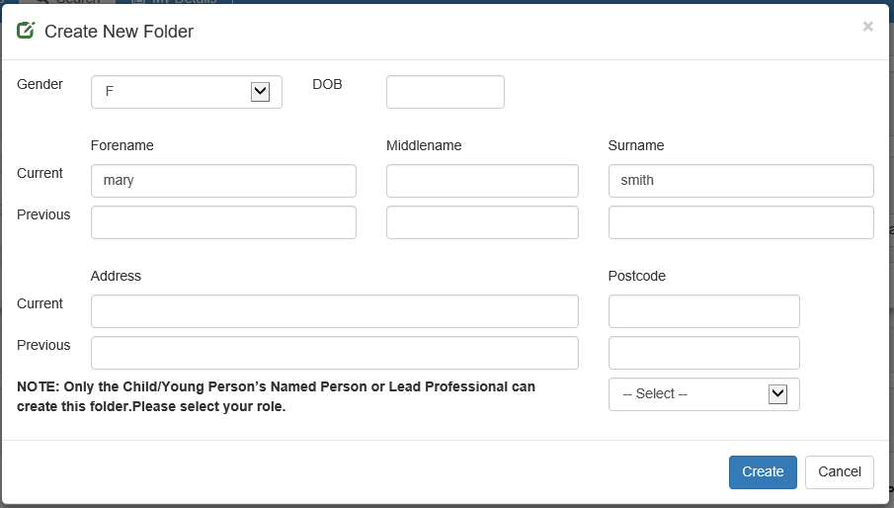

Only the NP/LP can create a new folder or approve the creation of a new folder by a Local Admin user.

# FOLDERS

The layout of a Child/Young Person’s folder will differ depending on your level of access.

The first diagram below shows a folder from an Ordinary User’s point of view and the second shows it from a NP/LP’s point of view.

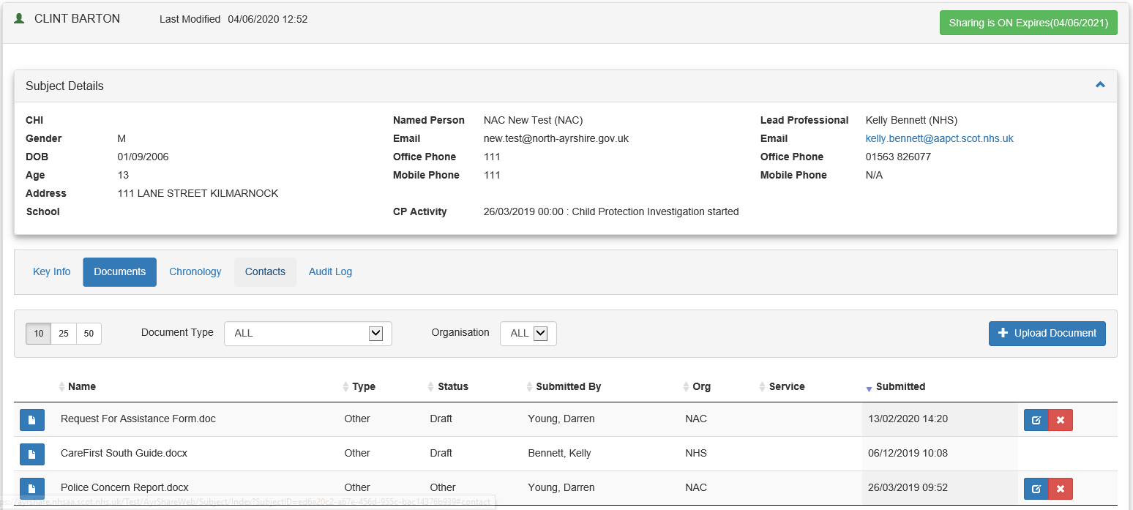

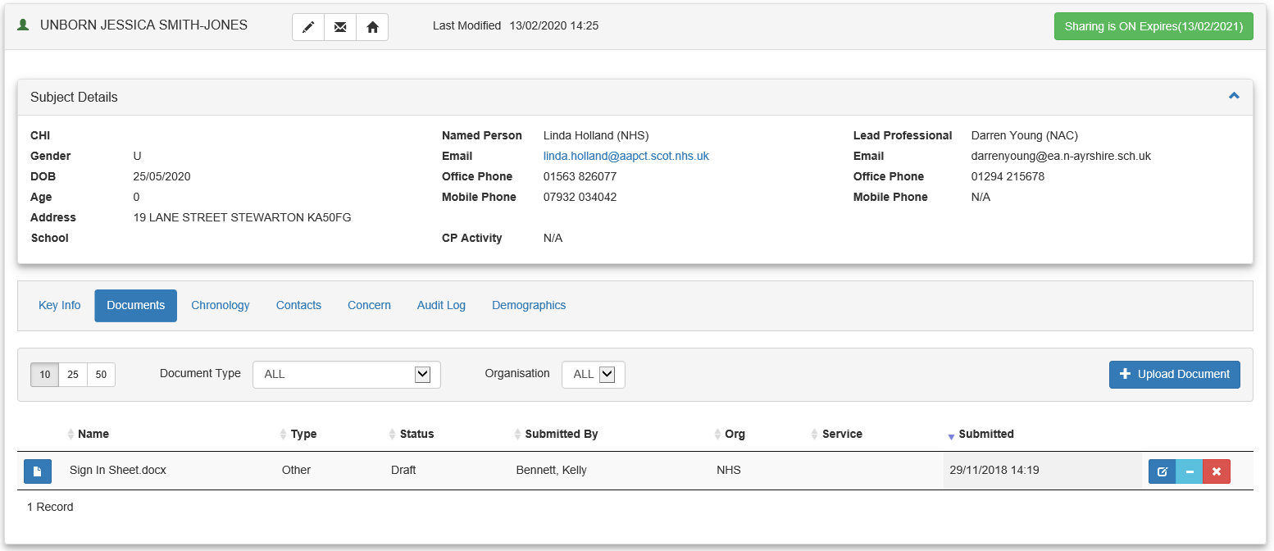

Both screens show the Child/Young Person’s:

* Demographic details:
  + CHI – Community Health Index number
  + Gender – Male, Female or Unborn
  + DOB – Date of Birth in format dd/mm/yyyy
  + Age – calculated from the Date of Birth
  + Address – including Post Code
  + School – School or Nursery Details
* NP/LP’s contact information
  + Name (Organisation)
  + Email address
  + Telephone Numbers – Office and Mobile
* Last Modified – the date and time when the folder was last updated

Both screens also allow you to stop/start email notifications by clicking on the ‘Subscriptions’ button. This displays a pop up menu that allows you to control what type of email notifications to receive. By default, you receive an email notification whenever chronology is updated, a document is uploaded or when a Child/Young Person’s demographics have changed (Subject Update). To stop or restart notifications being sent by email automatically from the system remove the tick or reapply the tick to the check box.

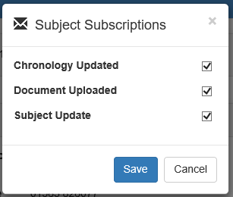

As a NP/LP, you have the additional ability to:

* Enable or disable the sharing of a Folder
* Set or extend an expiry date for the sharing of a folder

# 

# ENABLING OR DISABLING SHARING (NP/LP)

The process of enabling or disabling the sharing of a folder is as follows:

* Click on the Contacts tab and remove Contacts that no longer require access to folder as sharing is no longer required.
* Click on the button (this will be red if expired)
* This will bring up a dialogue box to allow you to turn sharing off by using the dropdown menu and clicking Save.
* Enabling sharing is done using the same process.

When sharing of the folder is turned off or has expired only the NP/LP or Local Admin will have access.

**SETTING AN EXPIRY DATE (NP/LP)**

Click on the button and fill in the expiry date then click Save.

# KEY INFO

The Key Info tab is the first tab in the record and allows all users to record relevant important information within a child’s folder that would not be recorded in a chronology event. E.g. ‘do not visit family alone, visit in pairs’. This tab should not be used for telephone messages. The information added can only be removed by the person who added it and has a character limit of 150.

Click on Key Info Tab then click on Add Key Info, fill in the information and click Save.

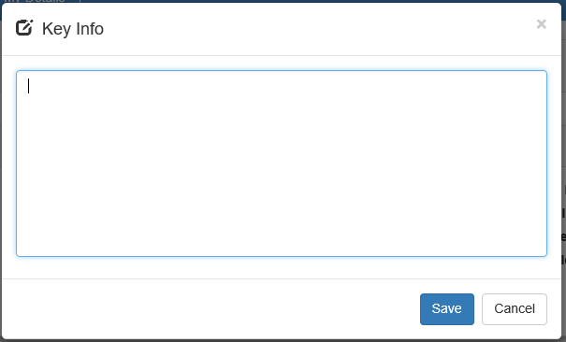

# DOCUMENTS

The Documents screen allows you to manually upload documents or view documents that are stored in the Child/Young Person’s folder.

When you open a Child/Young Person’s folder, the Document screen is already visible. You can open a document by clicking on the blue page icon. Uploaded documents are view only and cannot be changed on AYRshare unless you save the document to your hard drive and reupload it as a new document to AYRshare.

All Contacts have the ability to upload new documents to a Child/Young Person’s folder. Only the Child/Young Person’s NP/LP can delete a document from the folder. If the document has already been uploaded to a system linked to AYRshare (i.e. CareFirst and Care Partner) then this should be shared from that system to AYRshare instead of manually uploaded. A NP/LP can also withdraw a document.

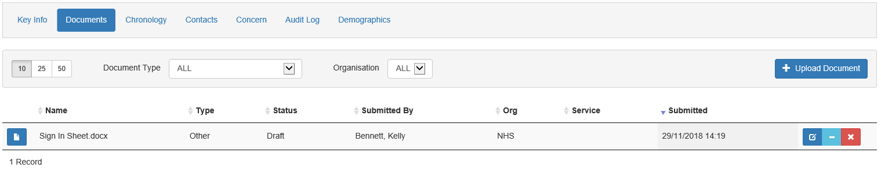

# UPLOADING A DOCUMENT

Although some users will be able to upload documents directly from their own organisations system, all linked Contacts will also have the ability to upload documents manually to a folder on AYRshare. It is very similar to attaching a file to an email. You can upload multiple different types of documents to AYRshare, including Microsoft Word and Adobe PDF files.

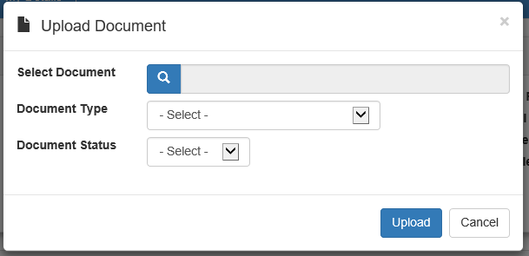

To upload a document:

* Click on the ‘Upload Document’ button.
* Click ‘the spyglass at Select Document to display documents stored on your computer or on your network and choose the document you wish to upload by clicking ‘Open’
* Select the ‘Document Type’
* Select the ‘Document Status’
* Click on the ‘Upload Document’ button to complete the upload

# DELETING A DOCUMENT (NP/LP)

As touched on earlier, as a NP/LP you can delete a document from a folder.

To delete a document click the ‘Red Cross’ next to the document you wish to delete, this will bring up a dialogue box asking ‘Delete Document. Are you sure?’ Click ‘Delete’ to delete the document.

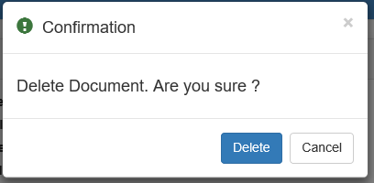

# WITHDRAWING A DOCUMENT (NP/LP)

Should you no longer wish to share a document with Contacts but still wish to the view the document as the NP/LP you can withdraw the document.

To withdraw a document click on the ‘Blue Minus’ sign next to the document you wish to withdraw this show a box asking ‘Withdraw Document. Are you sure?’ Click Withdraw and the document will still be accessible to NP/LP but hidden from contacts. To reactivate the withdrawn document click on the ‘Yellow Plus’ sign next to the document name.

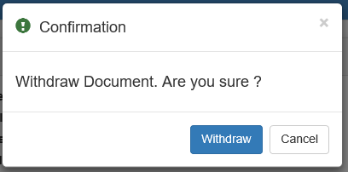

# EDITING A DOCUMENT (NP/LP)

The NP/LP and Person who uploaded the document has the ability to edit the document name, type and status by clicking on the ‘Blue Pencil’ icon. It should be noted that documents uploaded to the system cannot be edited, only the name of the document, type and status can be edited.

# CHRONOLOGY

The Chronology screen shows significant events recorded about a Child/Young Person. ‘Significant Events’ can be pushed from other systems, such as CareFirst, Liquid Logic and Care Partner to AYRshare or manually added.

All users can view chronology and add new chronology events on AYRshare. Chronology events should ONLY be added manually if the User does not have access to Care First, Liquid Logic or Care Partner.

Only an NP/LP has the ability to delete or edit existing chronology events. To enter a Child/Young Person’s chronology page click on the Chronology tab in a Child/Young Person’s folder.

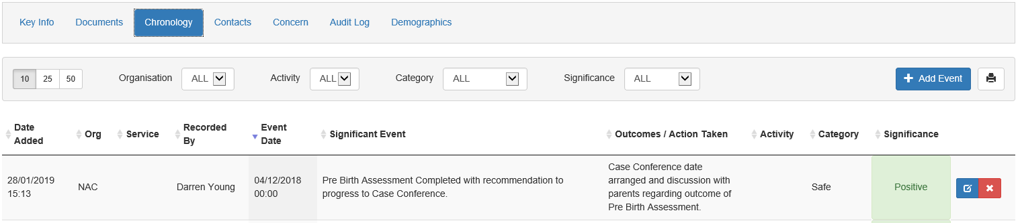

Chronology uses a traffic light approach to show the significance of the event.

If a manual Chronology event is required, you will select ‘+ Add Event’

* Enter who recorded the event and the date and time it occurred
* Describe the ‘Significant Event’ (250 character limit).
* ‘CP Event’ – this is for designated admin at present and should not be used by any other user
* Input the Outcomes/Action Taken (500 character limit).
* Select a category from the drop down options (SHANARRI)
* Select the significance of the event for the drop down option
* Click on the ‘Save’ button to insert the chronology

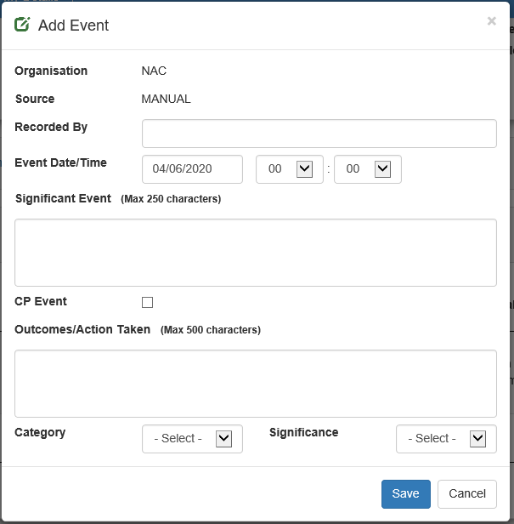

Whether chronology events are electronically sent from your own organisations computer system or added manually, they are filtered into the list by the event date. As AYRshare filters the significant event into the correct event date it will not always be the last event added at the top of the list.

This may not necessarily be the most recent event and not be shown on the top row. However, users can filter the chronology by clicking the arrows next to each column header.

System users can print Chronology by clicking on the print icon, and then right click on the page and print as normal.

The number displayed at the bottom left of the chronology is the total number of significant events in the folder.

As NP/LP, you also have the ability to:

* Delete significant event by clicking the ‘Red Cross’
* Edit a significant event using the ‘Blue Pencil’ icon. To save any changes click the ‘save’ icon or to cancel the changes click the cancel button.

# CHILD PROTECTION MESSAGING

AYRshare is being used at present for Child Protection Messaging. When you open a folder, you will see straight away if the Child/Young Person has had any ‘Child Protection Activity’ under the heading of ‘CP Activity’ next to the Child/Young Person’s demographics.



Child Protection events can either be pushed from a joint system e.g. CareFirst, CarePartner or Liquid Logic or manually added in the chronology section on AYRshare.

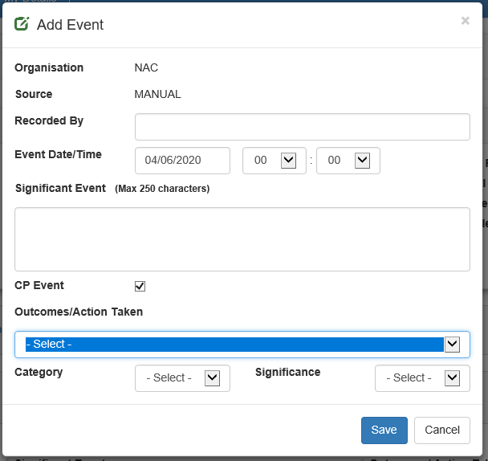

Child Protection messages are clearly marked in the chronology by having ‘CP’ under Activity column. You can manually add a CP event in much the same way as adding a significant event except that the CP event box must be ticked and a message selected from the drop down options.

By ticking the CP event box, the Outcomes/Action Taken section will have set responses instead of a text box.

Once you have selected the relevant message you would fill in the rest of the fields as you would with chronology and click on ‘Save’ to add the Child Protection Event.

# CONTACTS

To view the Child/Young Person’s contacts page click on the Contacts tab in the Child/Young Person’s folder.

The Contacts screen shows every user that has access to the folder. An Ordinary Contact will be able to view the contacts list and will be able to remove themselves from a record if they are no longer involved with the relevant child.

As a NP/LP, you have more options on this screen. You have the ability to both delete and add a new contact.

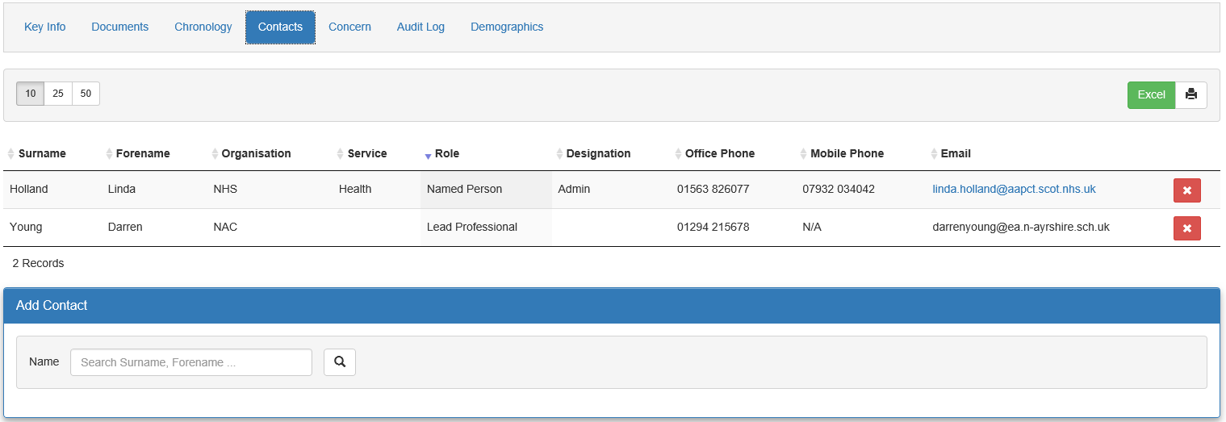

Click on the ‘Red Cross’ icon to delete a contact.

To add a new contact search for the system user you wish to add in the box under ‘Add Contact’. When searching for a User, search using ONLY the Users “surname” or “forename”. If the Person you search for does not appear in the search results this is most likely due to them not having an AYRshare account.

From the Search Results you can click on the ‘Blue Plus’ then choose the appropriate role select Contact, Lead Professional or Named Person. After selecting the role, click on the ‘Add’ button in order to complete the addition of the new contact.

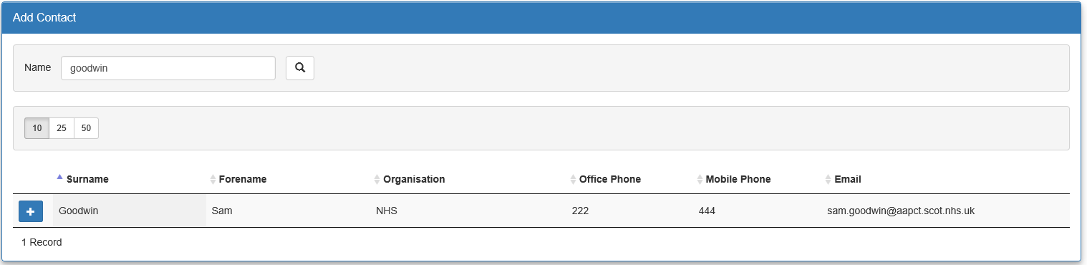

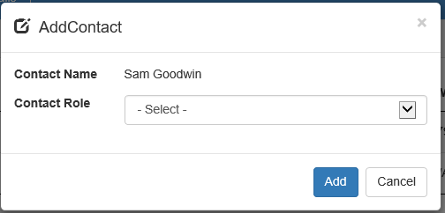

# CONCERNS

When a concern form is added by a Notifier or System Admin, a concern tab will appear for the NP/LP but is not visible to other Contacts. The NP/LP should click on the ‘Blue Page’ next to the concern and open it. Once read a chronology entry should be added.

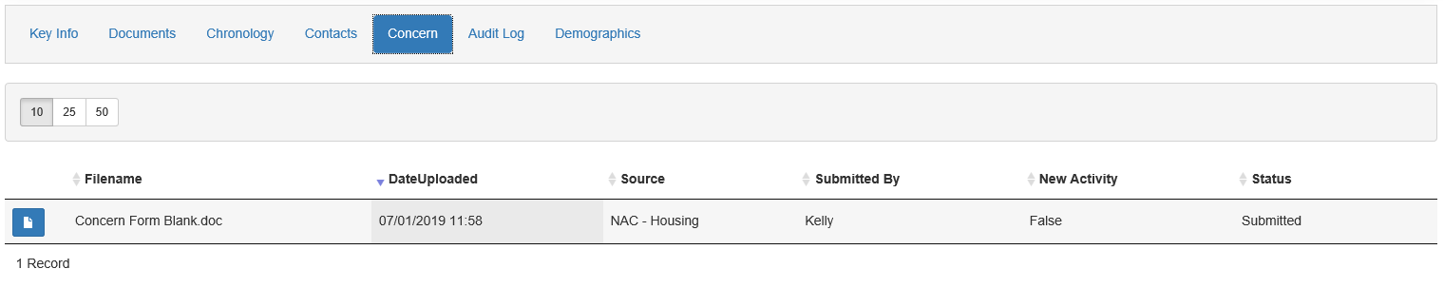

# AUDIT LOG (NP/LP)

As NP/LP, you have access to an Audit log for the Child/Young Person’s folder. This allows you to monitor any changes made to the folder and allows you to keep track of who has been viewing and editing the folder. To view the audit log click the last tab in the Child/Young Person’s folder.

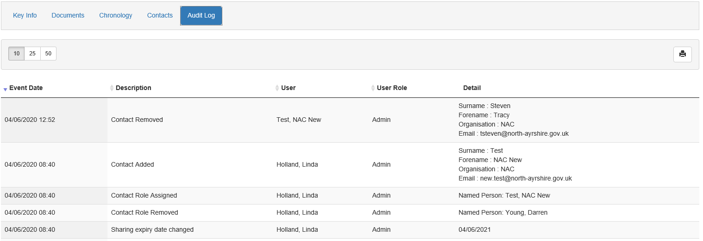

# ACTIVITY LOG

A QC user and an Ordinary Contact on a Child/Young Person’s folder will have access to the Activity log, which is similar to the audit log but does not contain as much information.

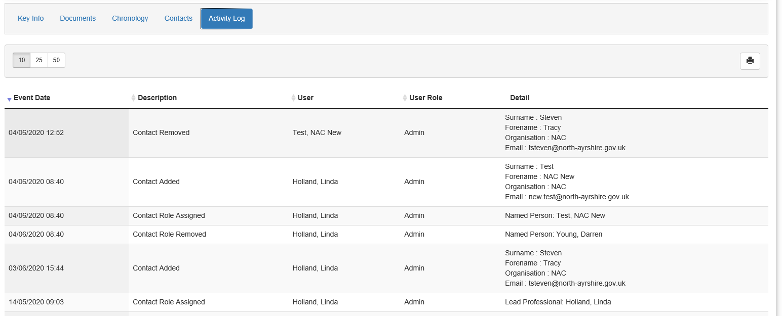

# DEMOGRAPHICS

This tab allows NP/LP and Local Admin to change the address field on any AYRshare record that they are NP/LP on. This is a free text field.

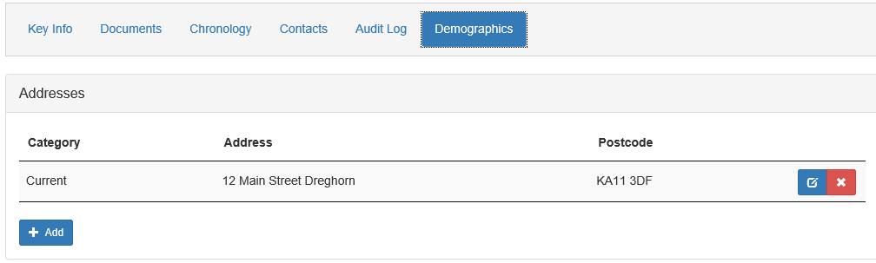

To make an address non disclosure click on the ‘House’ icon:



You should then see the following box, select the option you need then click Save.

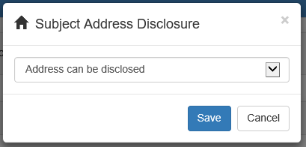

# MY DETAILS

My Details screen allows you to change your basic details.

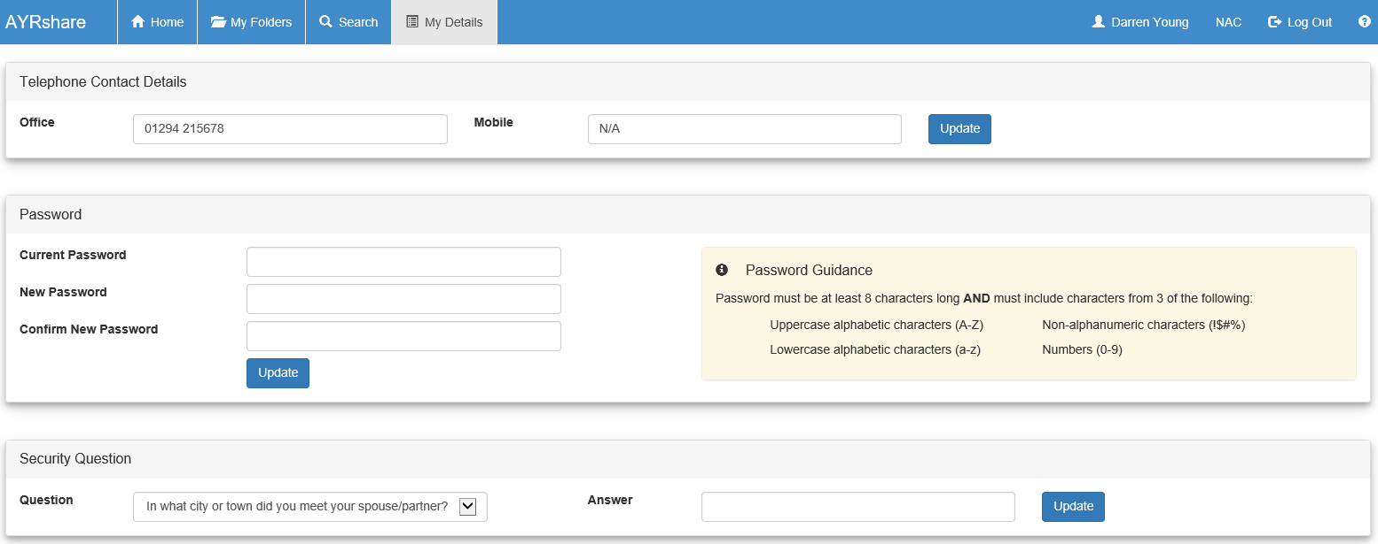

If you need to make any other changes to your details then you will need to contact AYRshare System Administration Team.

# PASSWORD RESET

In the My Details tab, there is an option to choose a security question. Upon picking a security question, you should then type an answer in the answer box below. You should then click ‘Update’. Security Answer must contain at least six characters. Completing this section allows you to reset your password without contacting AYRshare System Administration Team. In order for this function to work, you must have verified your email address in AYRshare. The system automatically disables user accounts due to inactivity. The system user will be required to contact AYRshare Systems Administrator to have their accounts reactivated before they can reset their own password.

To reset your own password from the login screen follow the steps below:

* At the login screen click on ‘I have forgotten my password’

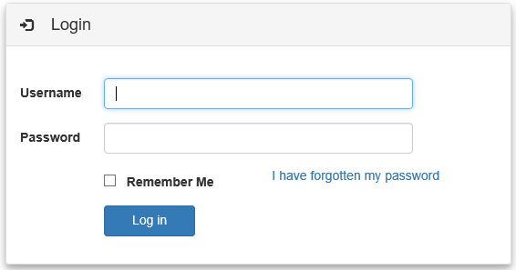

* A new dialogue box opens. Type in your username and click ‘Submit’

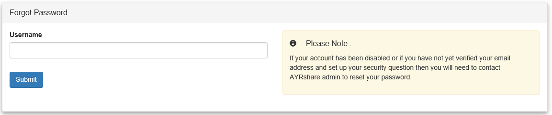

* Another dialogue box will open where you can type in the answer to your security question. Click ‘Submit’

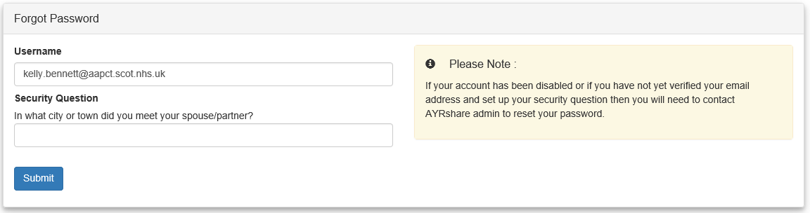

* The screen information now tells you a password reset link has been sent to your email address and to check your inbox for further details
* From your email, click the link to be directed to the ‘Password Reset’ box and type your username, new 8-character password then confirm this password. Click ‘Submit’
* If you do not set a Security Question within the system, you will be unable to use this service, and will have to either telephone or e-mail AYRshare Admin to reset your password. Please note, if you are sending an e-mail asking for your password to be reset, please ensure that you tell us who you are on the e-mail.

# REPORTING ISSUES/FAULTS WITH THE SYSTEM

If you are experiencing any issues with the system then it is important that you log the issue with AYRshare System Administration Team. Their contact details appear at the bottom of each screen on AYRshare.



Clicking on ‘Contact Admin’ button will open a new screen where you type and send your query.

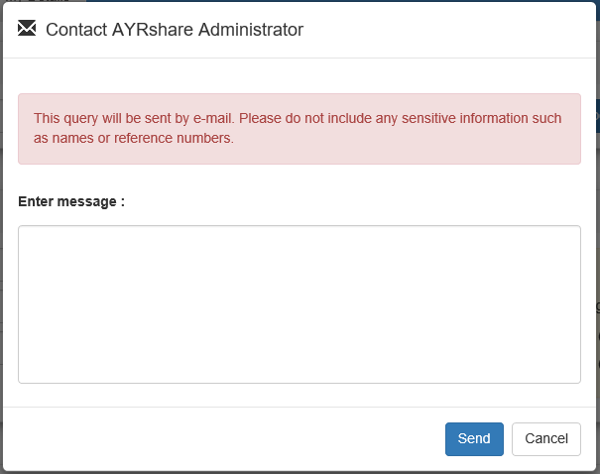

You can also speak to the AYRshare System Administration Team directly using the telephone number displayed next to AYRshare Admin.

The AYRshare System Administration Team will then work to resolve the issue as quickly as possible and will advise you of the outcome.

# 

# HELP SECTION

All users have access to the Help section. This holds relevant documents such as an up to date user guide and release notes for any new updates. To access the Help section users can click on the ‘Question Mark’ found in the top right corner of every page.

Here you can select the document you wish to use to aid you in your use of AYRshare.

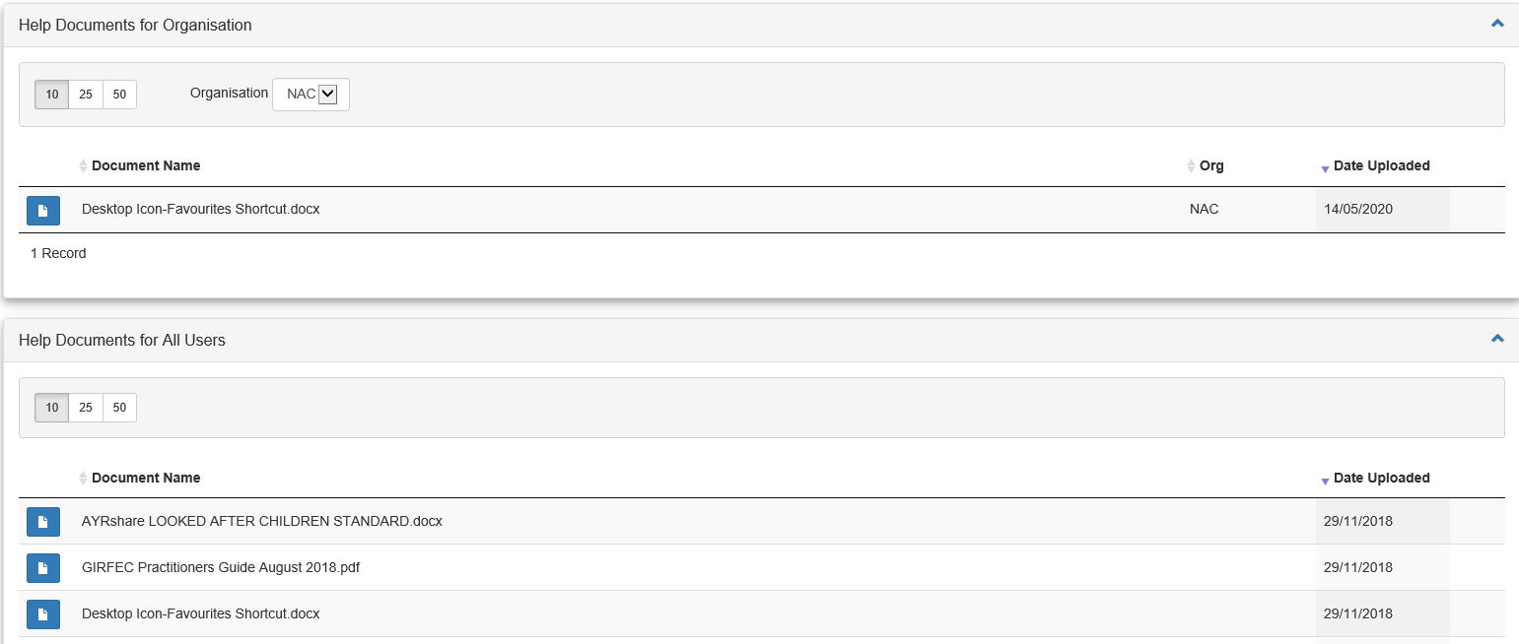

When you access the Help Section, you will automatically default to your own organisations documents, however, you can then access all documents from the lower half of the screen.

# LOGGING OUT

When finished using AYRshare all users should log out by clicking on the ‘Logout’ button found in the right hand corner of screen under the AYRshare logo.

AYRshare will automatically log you out if it has been idle for 20 minutes.

SECURITY ADVICE - It should be noted that if a User presses the X button to log out, it will look as though they are completely logged out, but should they have AYRshare on their desktop as a shortcut, and then leave the Laptop/PC unattended, anyone can click on the shortcut and gain access to the account. A User will remain logged in behind the scenes for 20 minutes. We would always advise Users to use the Logout option instead of the X unless the Laptop/PC they are using is going to be switched off.