GETTING
August 2023 Version 1.1
IT
RIGHT
FOR EVERY CHILD in AYRSHIRE
Named Person Service in North Ayrshire | For more information  Access www.girfec-ayrshire.co.uk  Contact the named person for children and young people in North Ayrshire through the Named Person Service e-mail, as follows:  namedpersonservice@north-ayrshire.gov.uk  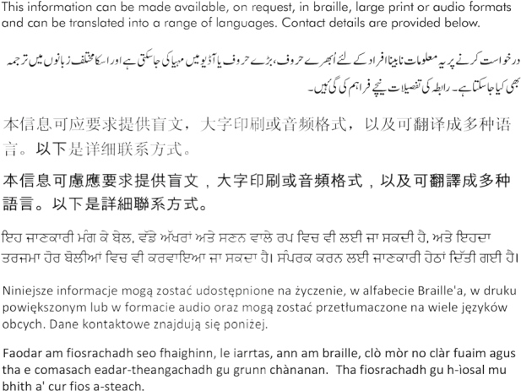
Getting It Right for Every Child (GIRFEC) is the national approach in Scotland to support and improve the wellbeing of our children and young people, by offering the right help, at the right time, from the right people.

The named person is a professional within Health or Educational Services who is responsible for promoting, supporting and safeguarding the wellbeing of children and young people.

Parents, carers, wider family members and the community provide most children and young people with the help and support they require. Through Getting it right for every child all children, young people and their families have access to a named person so that they can request extra support, advice or sign posting to other services when they need it.

Every child and young person has a named person until they reach the age of 18 years old or until they leave school if over the age of 18.

The named person works with children, young people and their families to improve wellbeing and help each child/young person achieve their potential. If the named person requires to share information to achieve this, they will ask for informed agreement from the child/young person’s parent(s)/carer(s), unless there are child protection concerns.

There is no obligation to accept the offer of advice or support from the named person. The views of all those involved will be considered and recorded.

