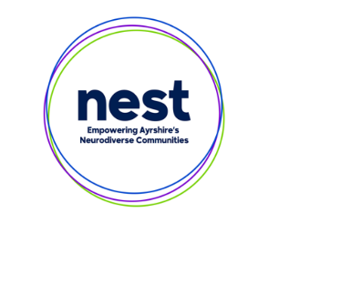**Service Information Pro Forma**

**NEST Website**

By returning this completed form, you are giving us permission to share the information publicly on our website [www.nest.scot](http://www.nest.scot)

Please note, it is your responsibility to let us know if any details change or if you would like your service information removed from our website in the future.

Once complete, please email the form — along with a log and cover photo — to: [celine.dyer@aapct.scot.nhs.uk](mailto:celine.dyer@aapct.scot.nhs.uk)

**Service Name**

|  |
| --- |
|  |

**Who We Are?**

|  |
| --- |
|  |

**Service Description (What we do)**

|  |
| --- |
|  |

**Area (Select ONE only):**

[ ] Arran

[ ] Ayrshire Wide

[ ] East Ayrshire

[ ] North Ayrshire

[ ] South Ayrshire

[ ] East & South Ayrshire

[ ] East & North Ayrshire

[ ] South & North Ayrshire

[ ] Scotland Wide

[ ] UK Wide

**Type of Service (Select all that apply):**

[ ] ADHD

[ ] Autism

[ ] Carer Support

[ ] Childcare

[ ] Children’s Services Support

[ ] Communication

[ ] Community Paediatric Psychology Service

[ ] Community Service

[ ] Community Support

[ ] Dental Practice

[ ] Education Service

[ ] Employment Support

[ ] FASD

[ ] Food

[ ] Mental Health Service

[ ] Occupational Therapy

[ ] Optician

[ ] Shopping

[ ] Social Groups

[ ] Speech & Language Therapy

[ ] Sport/Leisure

[ ] Other: _______________________________

**How to Access/Contact**

|  |
| --- |
|  |

**Website URL**

|  |
| --- |
|  |

**Email Address (if applicable)**

|  |
| --- |
|  |

**Phone Number (if applicable)**

|  |
| --- |
|  |

**Address (if applicable)**

|  |
| --- |
|  |